F

Sage Gutierrez

Sgutierrez31@mail.valenciacollege.edu

Final project

VillainHideaway Documentation

Table of Contents

Original Planning Document 2

Network Diagram 5

ADDS Diagram 6

Shared Folders Diagram 7

Server 1(Orlando) Documentation 8

Server 2 (Anaheim) Documentation 10

Server 3 Documentation 15

Shared Folder Documentation 17

Storage Quotas 19

OU/Groups/Users Screenshots 27

*Client Documentation* 30

Group Policy Documentation 34

# Original Planning Document

**Project Information**

* **Project Theme:** Disney Villains Universe
* **Domain Name:** VillainHideaway.hub

**Server Information**

1. **OrlandoSG**
   * **Roles:** ADDS, DNS
   * **IP Address:** 10.10.10.32
   * **Subnet Mask:** 255.255.255.0
   * **Gateway:** None
   * **DNS:** 10.10.10.32
2. **AnaheimSG**
   * **Roles:** ADDS, DHCP
   * **IP Address:** 10.10.10.33
   * **Subnet Mask:** 255.255.255.0
   * **Gateway:** None
   * **DNS:** 10.10.10.32
3. **TokyoSG**
   * **Roles:** FRSM
   * **IP Address:** 10.10.10.34
   * **Subnet Mask:** 255.255.255.0
   * **Gateway:** None
   * **DNS:** 10.10.10.32

* **Operating System for All Servers:** Windows Server Datacenter
* **Domain Password:** Password01

**Organizational Unit (OU) 1**

* **Name:** Bad Deeds
* **Group Name:** G_BadDeeds
* **Users:**
  1. Captain Hook / Chook
  2. Hades / Hades
  3. Cruella de Vil / CdeVil

**Organizational Unit (OU) 2**

* **Name:** No Good Doers
* **Group Name:** G_NoGoodDoers
* **Users:**
  1. Gaston / Gaston
  2. Jafar / Jafar
  3. Queen of Hearts / QHearts
  4. Big Bad Wollf / BBWolf

**Organizational Unit (OU) 3**

* **Name:** Troublemakers
* **Group Name:** G_ Troublemakers
* **Users:**
  1. Ursula / Ursula
  2. Maleficent / Maleficent
  3. Scar / Scar
  4. Chernabog / Chernabog

**Network Equipment**

* **Switch #1 Name:** Hong Kong
* **Switch #2 Name:** Shanghai
* **Router Name:** Kissimmee

**Client Information**

* **Client Name:** Paris
* **Operating System:** Windows 10
* **IP Address:** DHCP
* **DHCP Scope:** 10.10.10.112 to 10.10.10.115

# Network Diagram

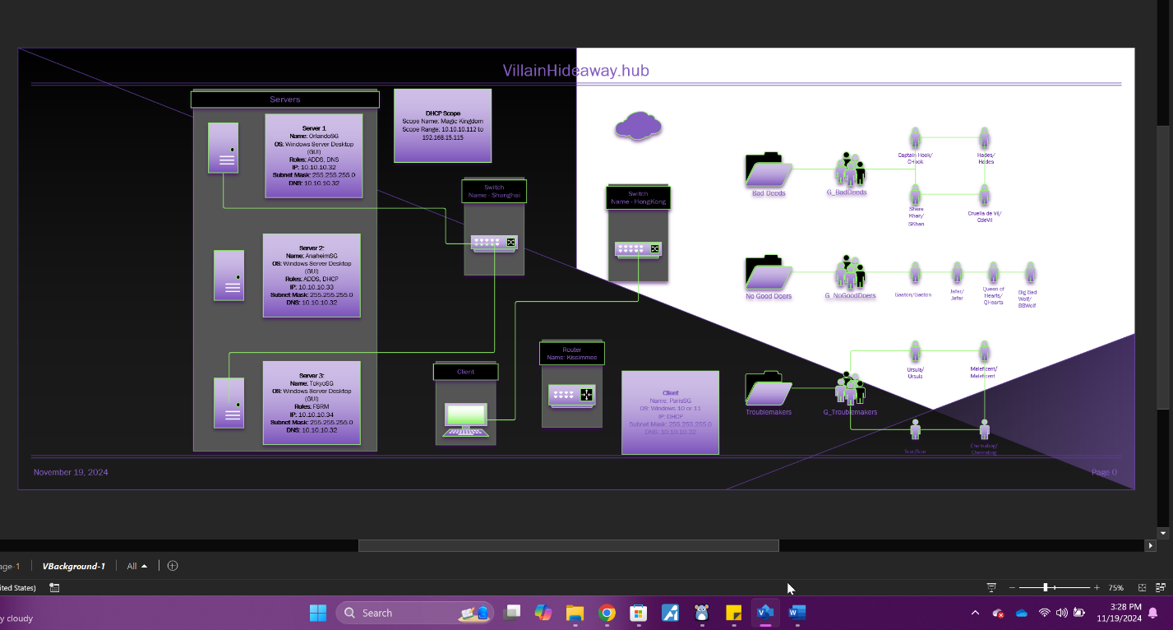

Network Diagram

# 

# ADDS Diagram

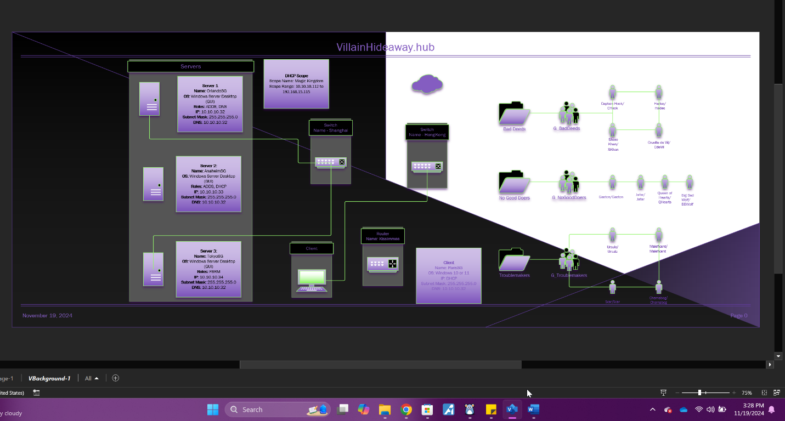  
ADDS Diagram

# Shared Folders Diagram A computer screen shot of a computer screen Description automatically generated Shared Folders Diagram

# Server 1(Orlando) Documentation A screenshot of a computer Description automatically generated Local Server (Orlando) Server Manager, Local Server information (showing the server being promoted to a DC)

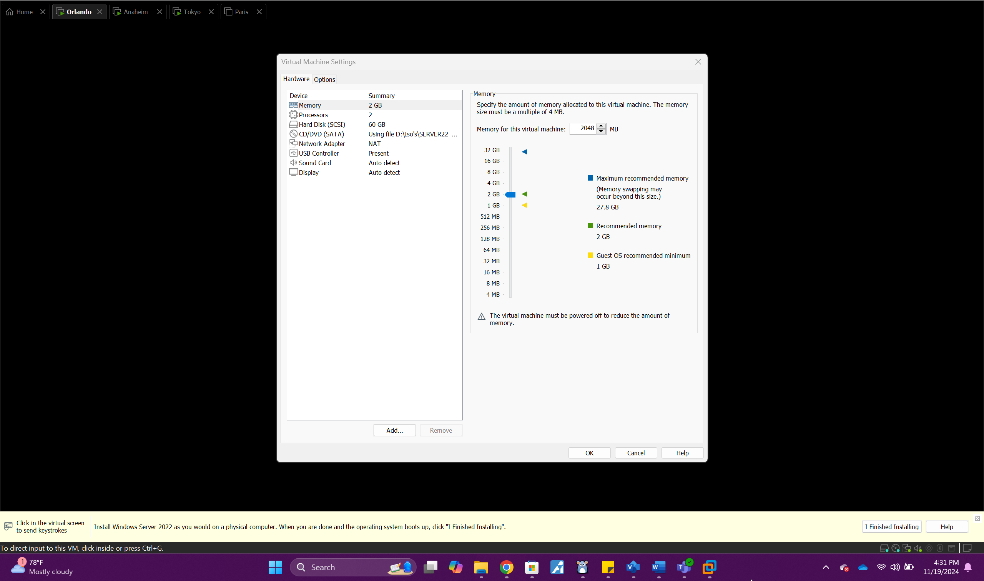  
*Orlando Hardware*

# Server 2 Documentation

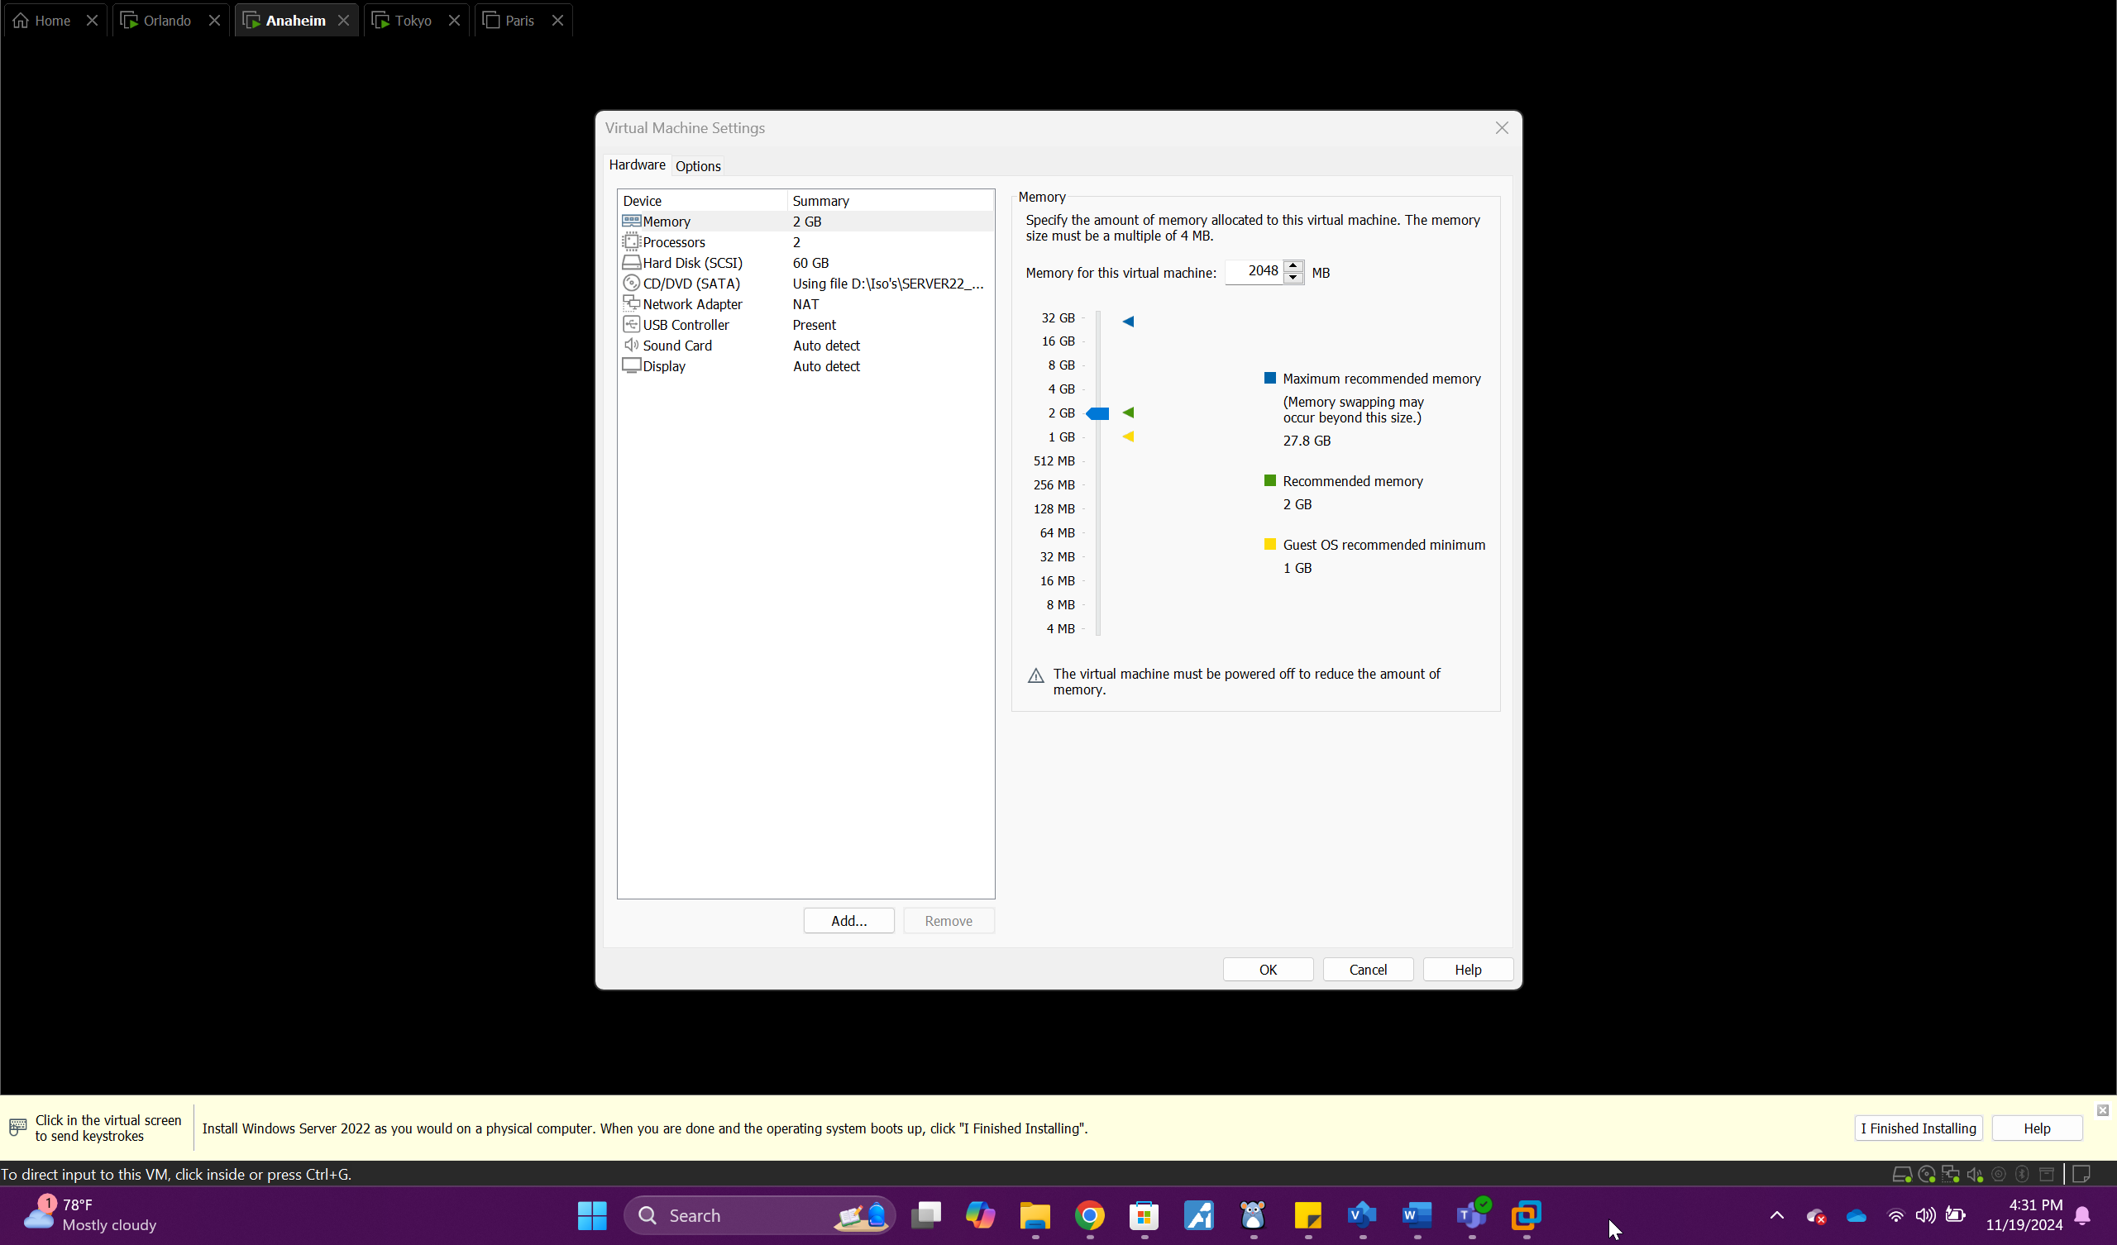 *Anaheim Hardware*

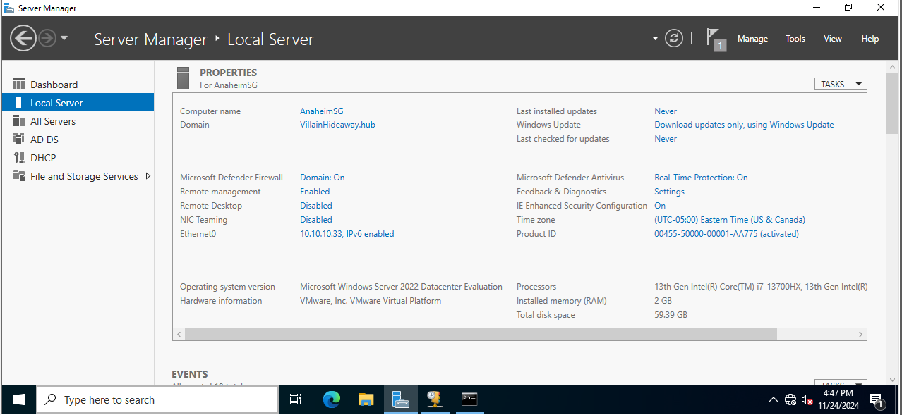*Local Server 2 – Anaheim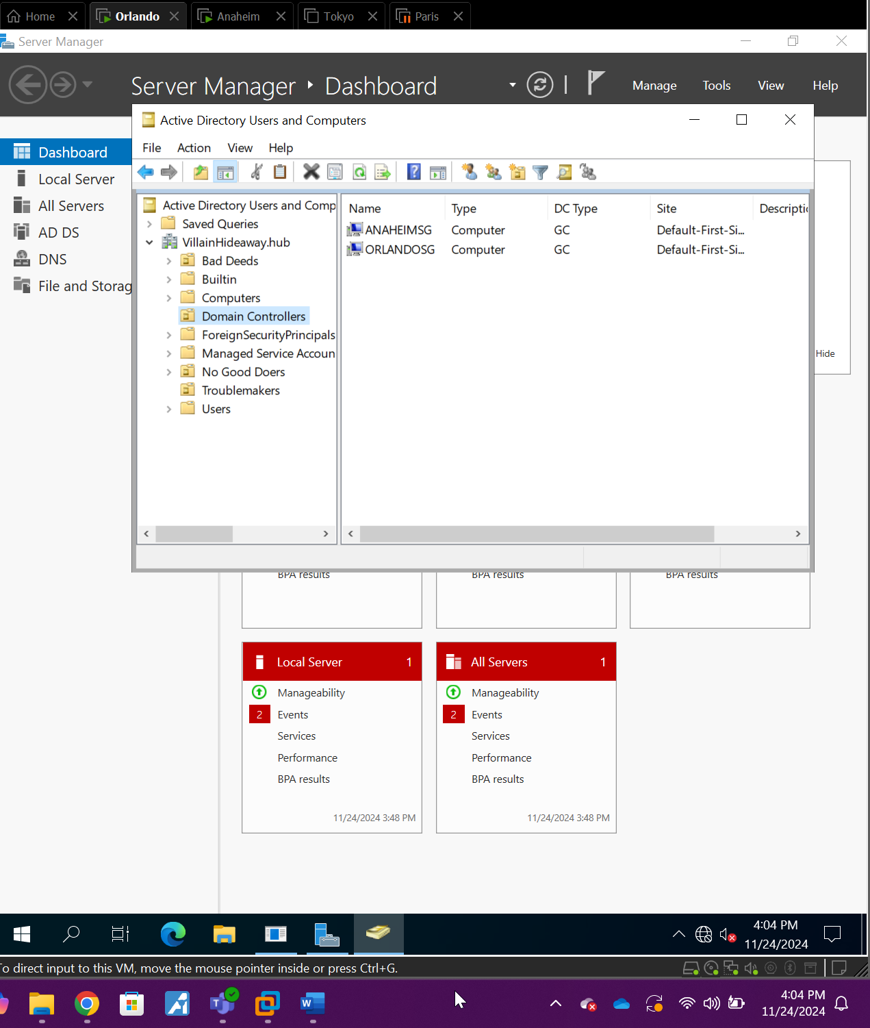Server 2 (ADCU)*

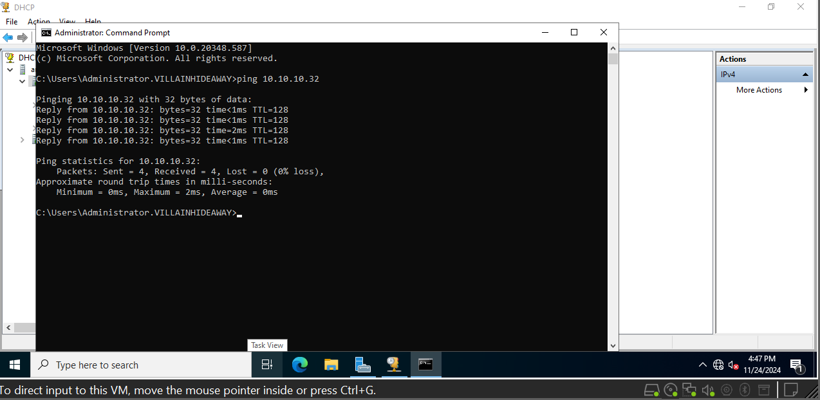Server 2 AnaheimSG – Successful Ping to DC

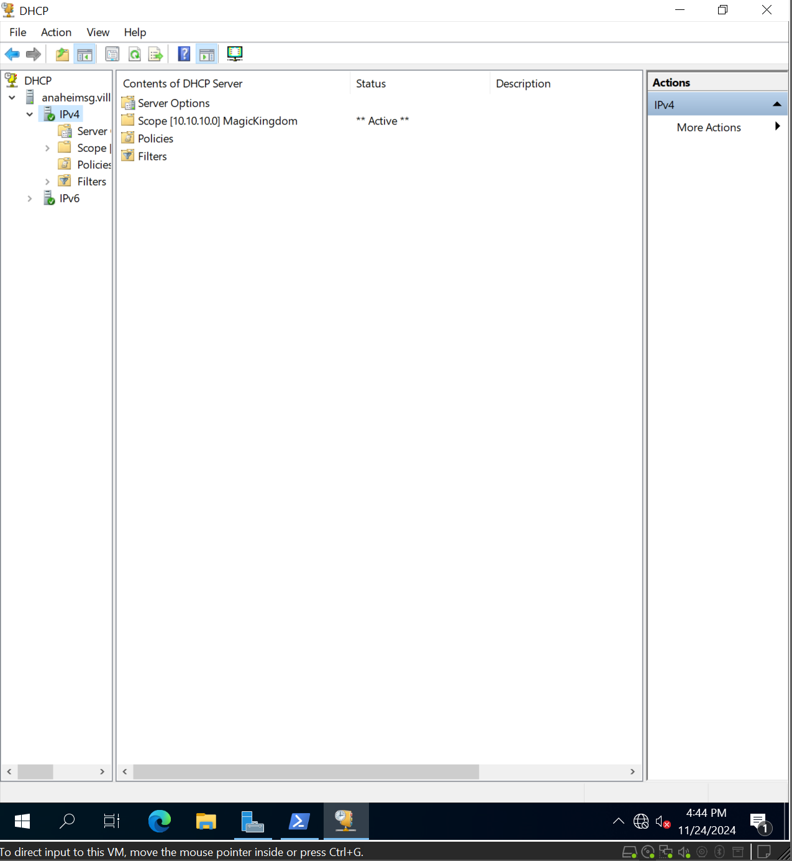Server 2 DHCP Scope

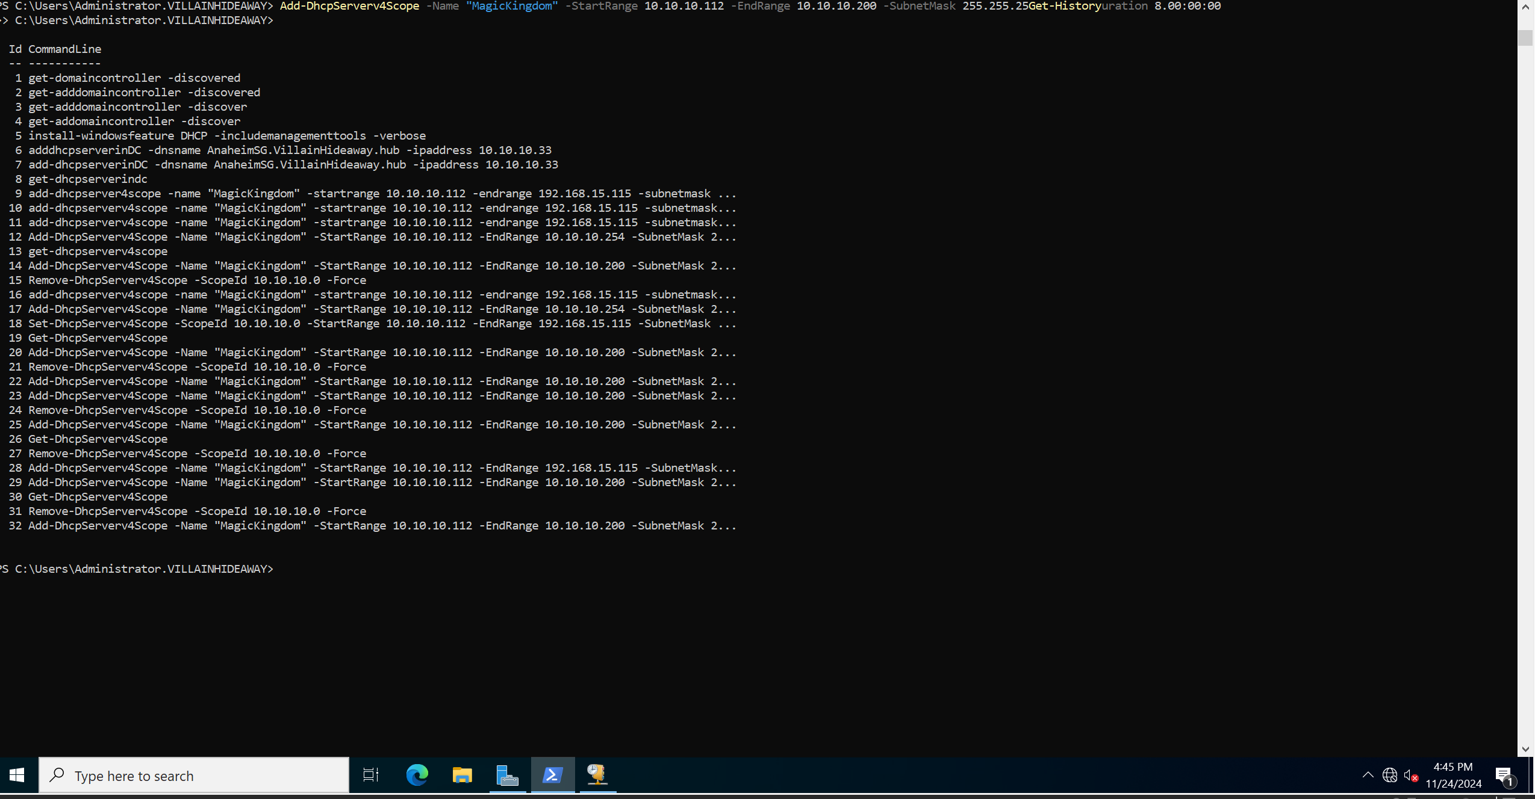  
*Powershell Commands used to add Server 2 (Anaheim)*

# Server 3 Documentation

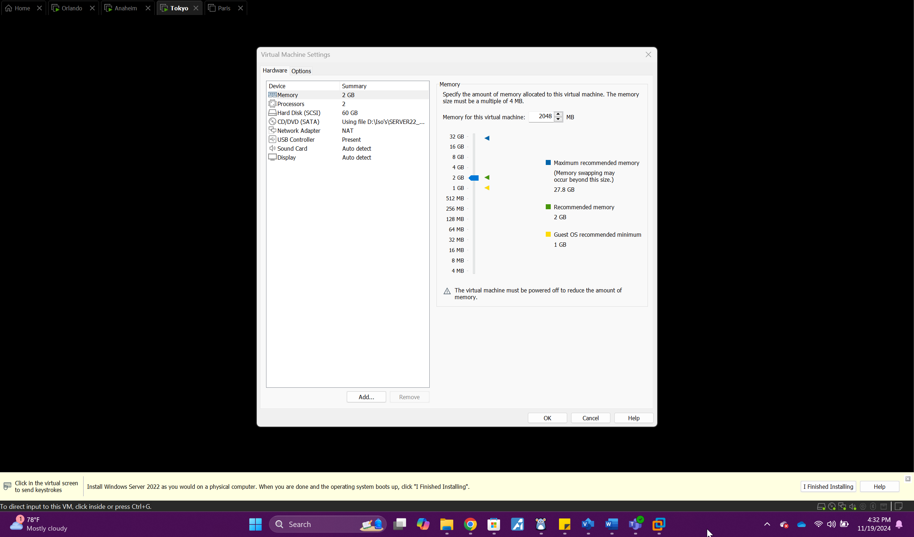 *TokyoSG Hardware*

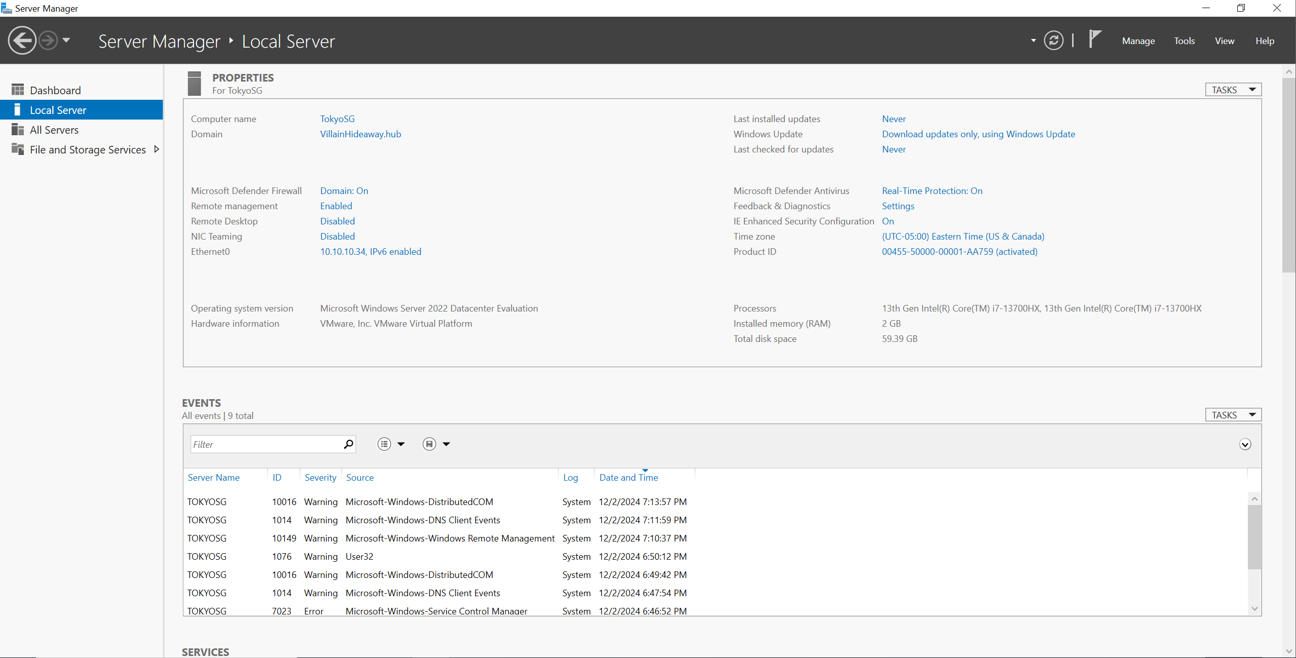  
*Local Server 3 (Tokyo FSRM Installed)*

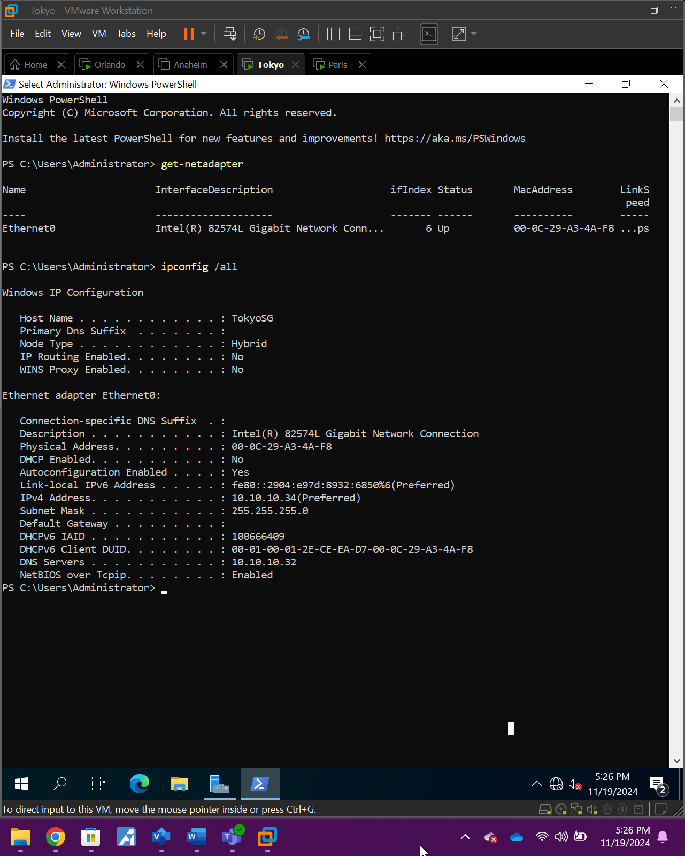 *TokyoSG ipconfig*

# Shared Folder Documentation

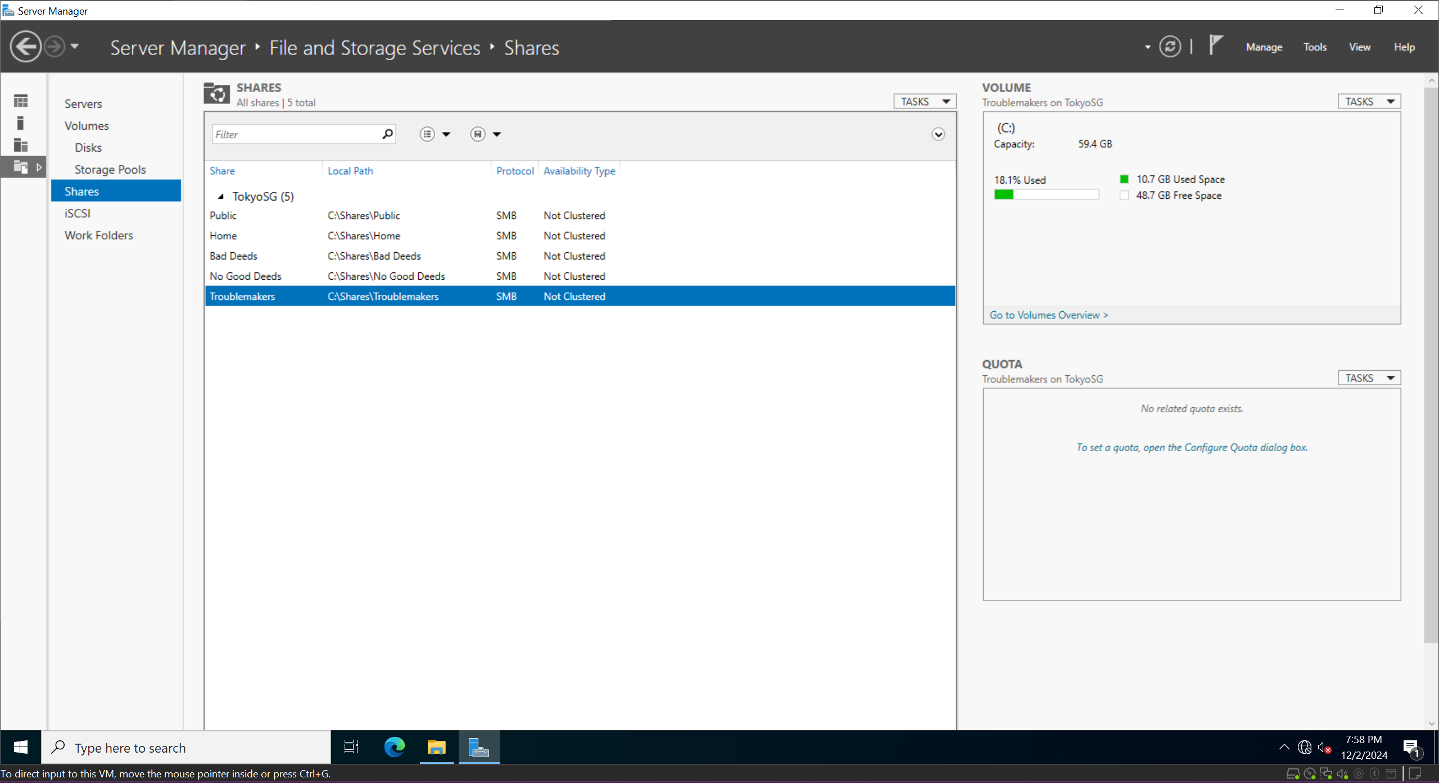Shared Folders on file server

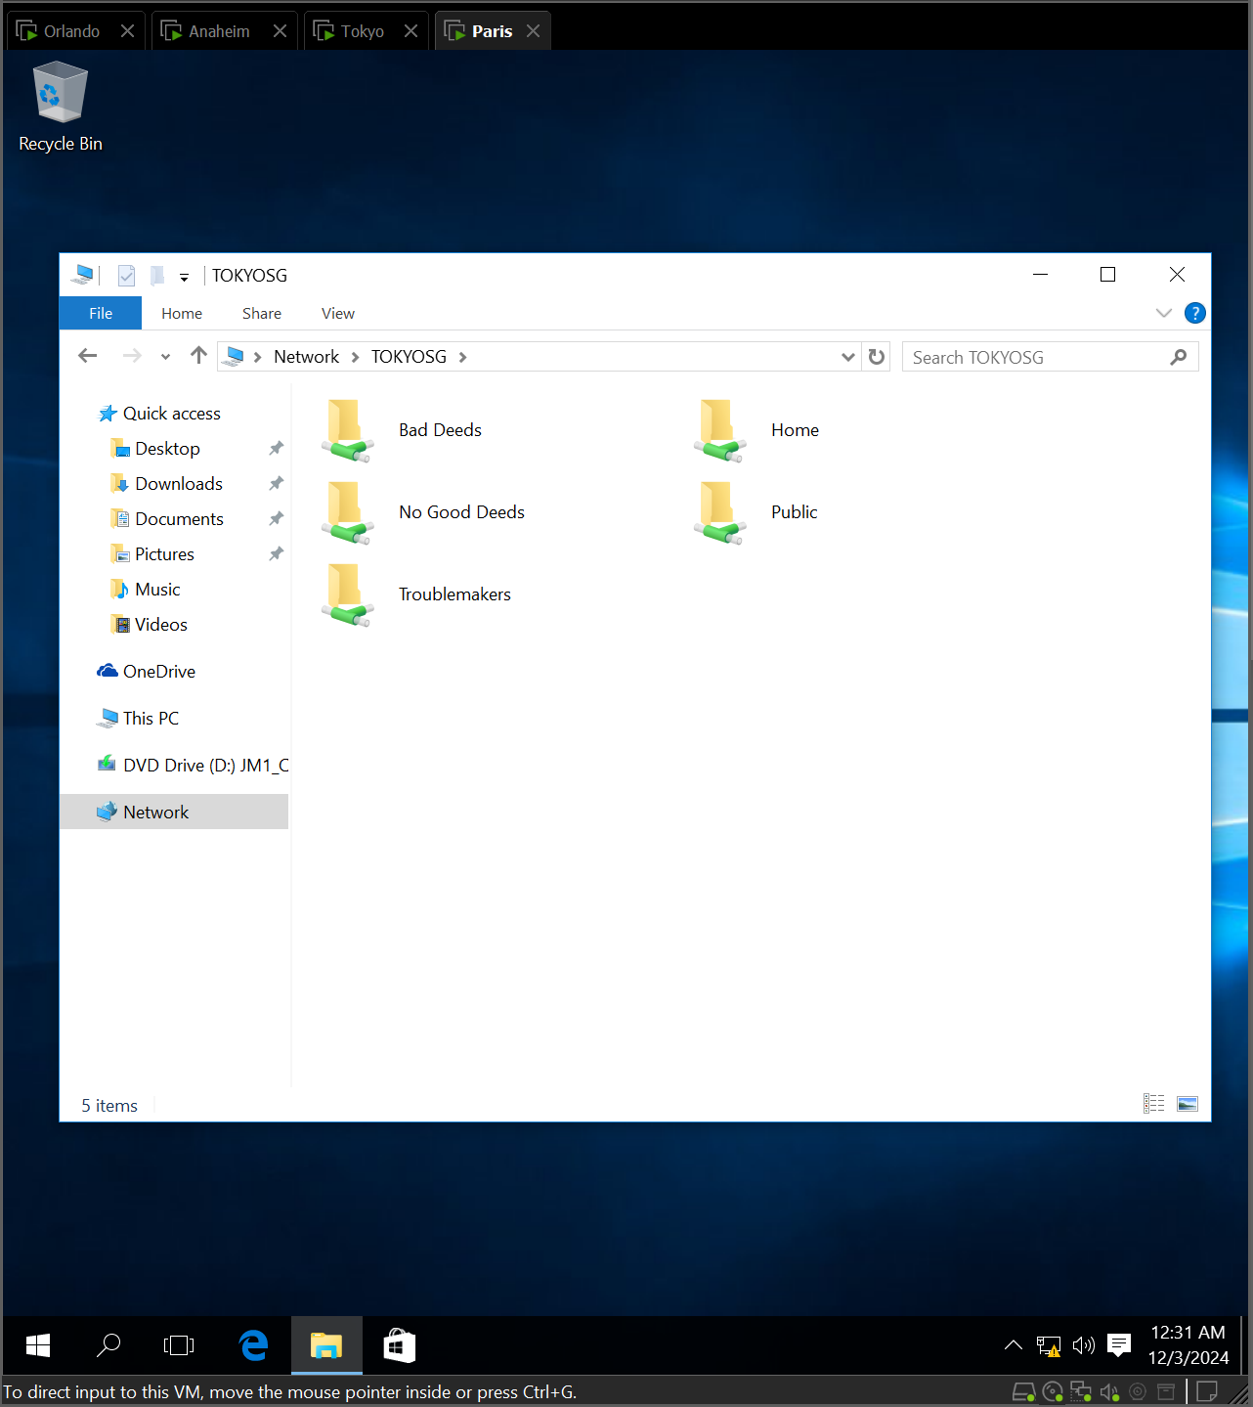  
Shared Folders on Client (ParisSG)

Storage Quotas  
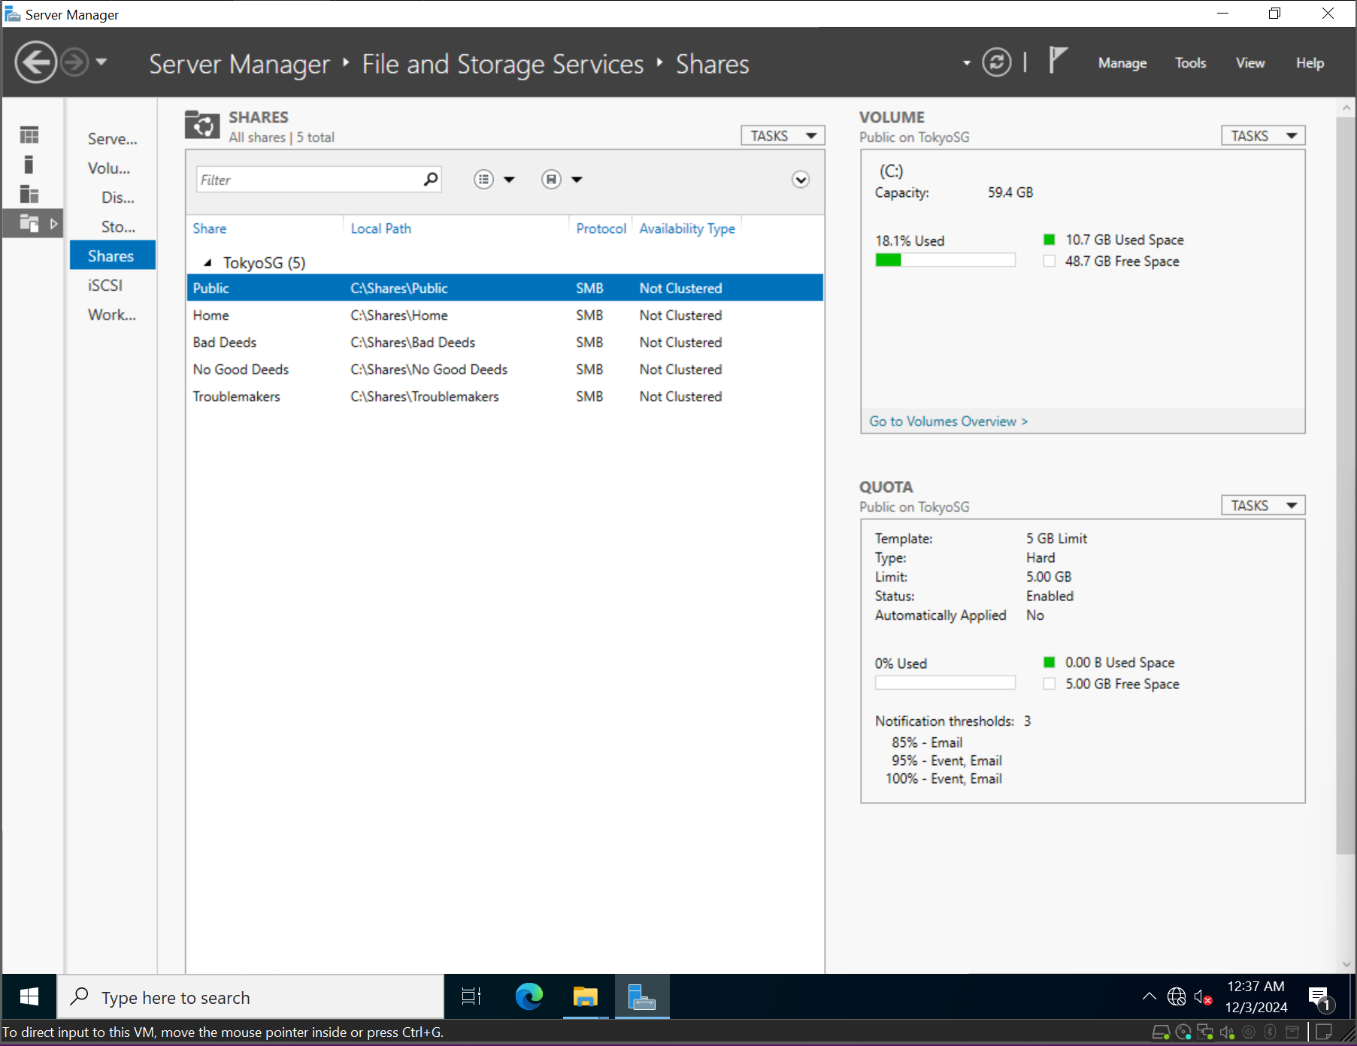  
*Public storage Quotas*

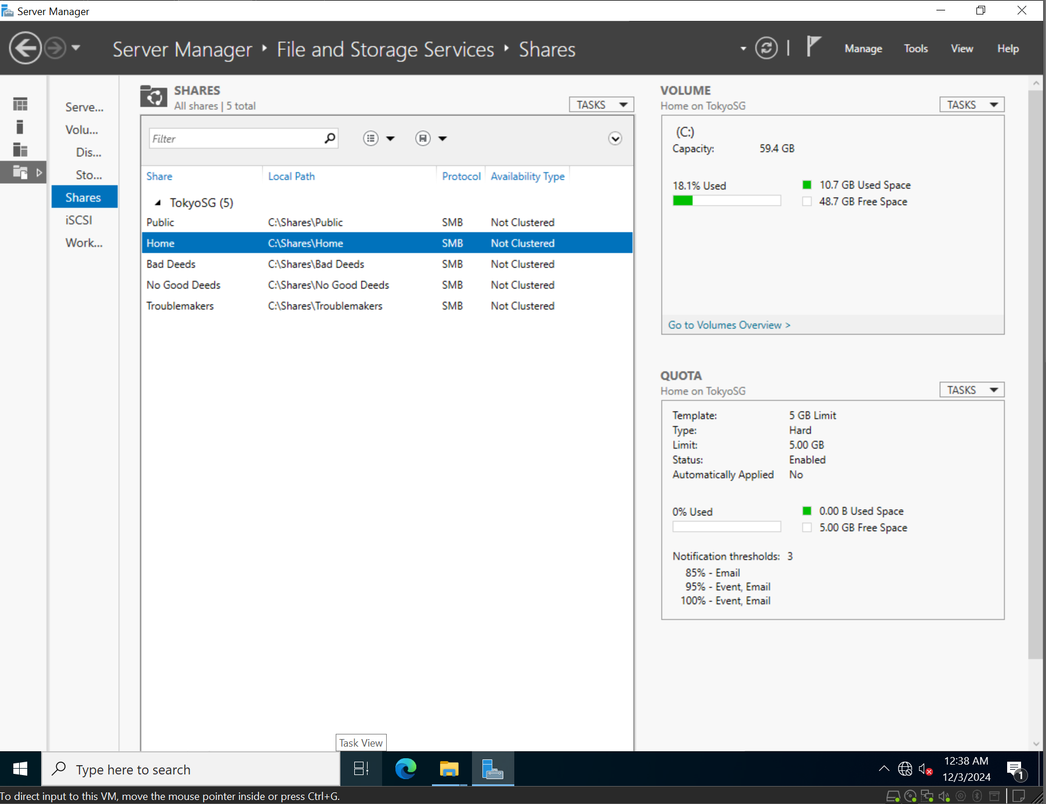  
*Home storage Quotas*

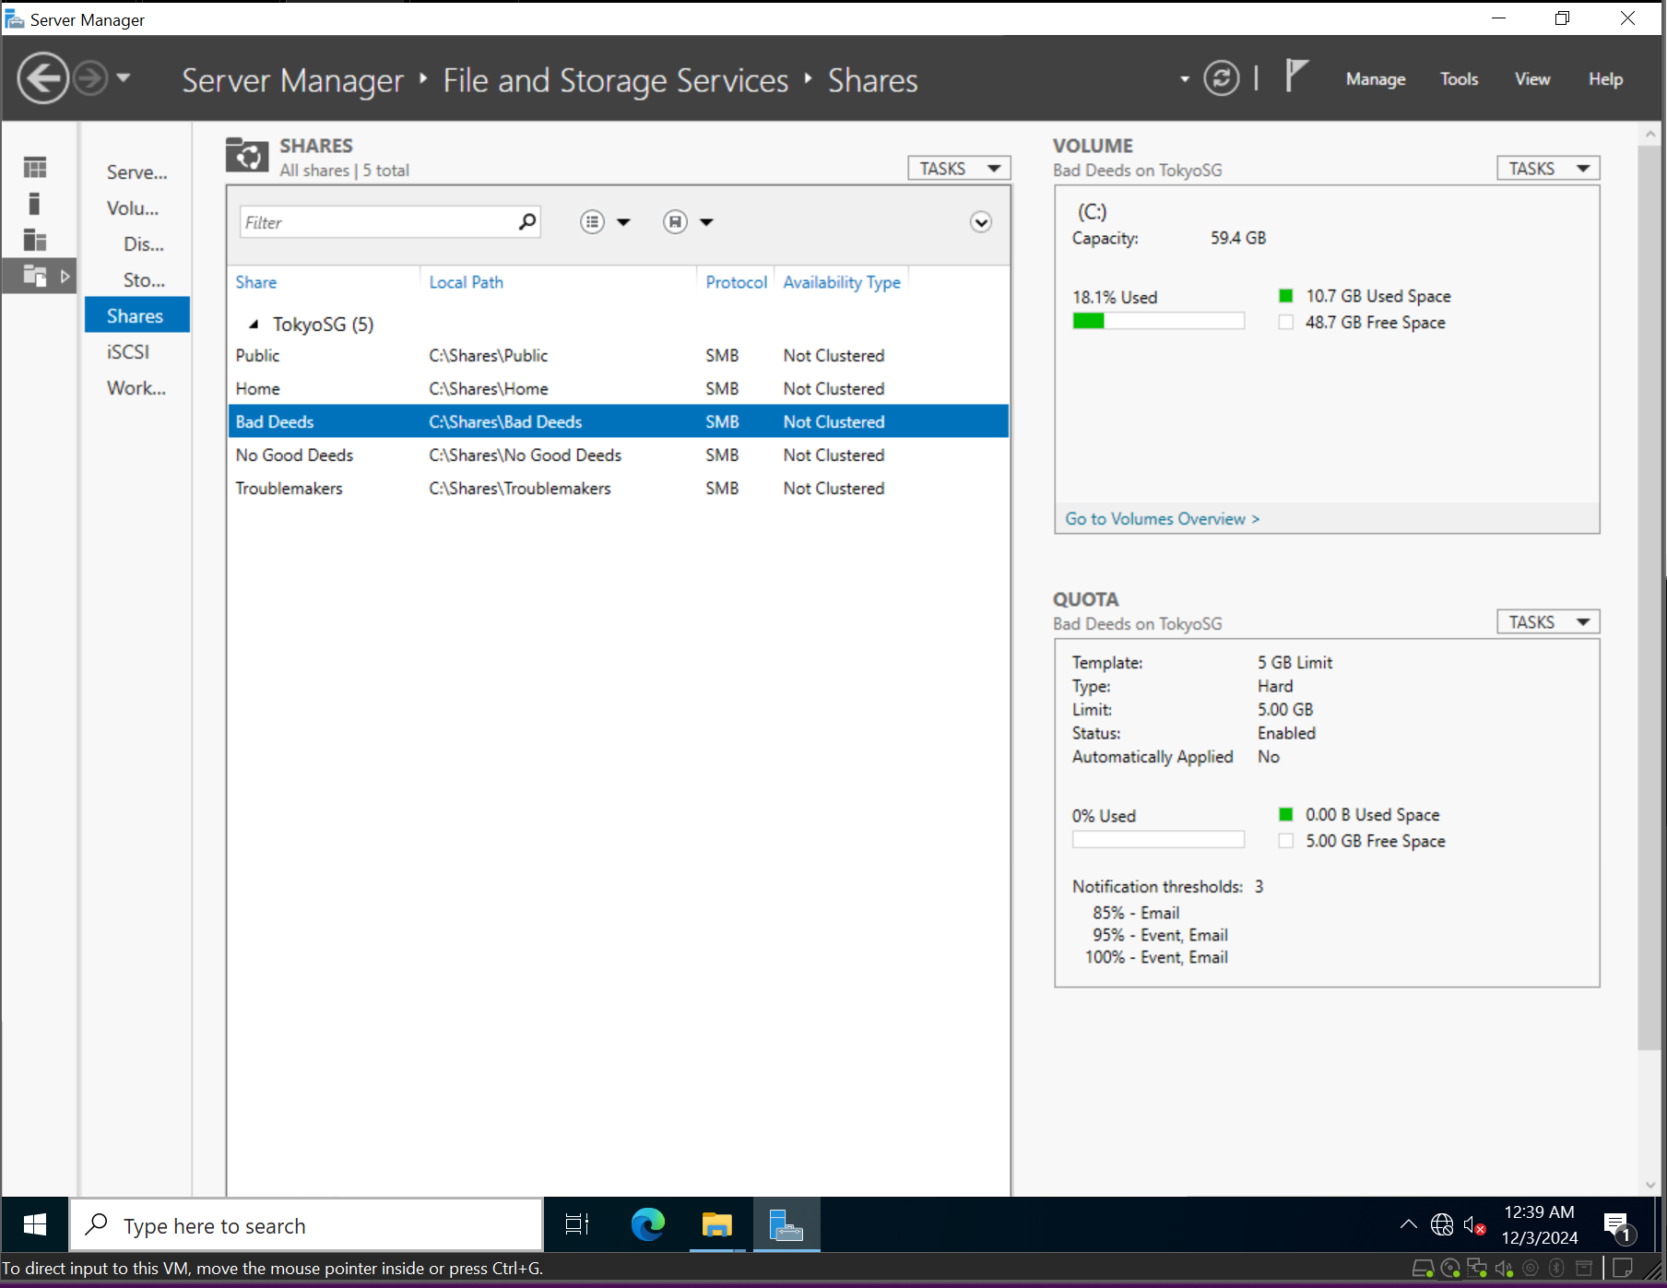  
*BadDeeds storage Quotas*

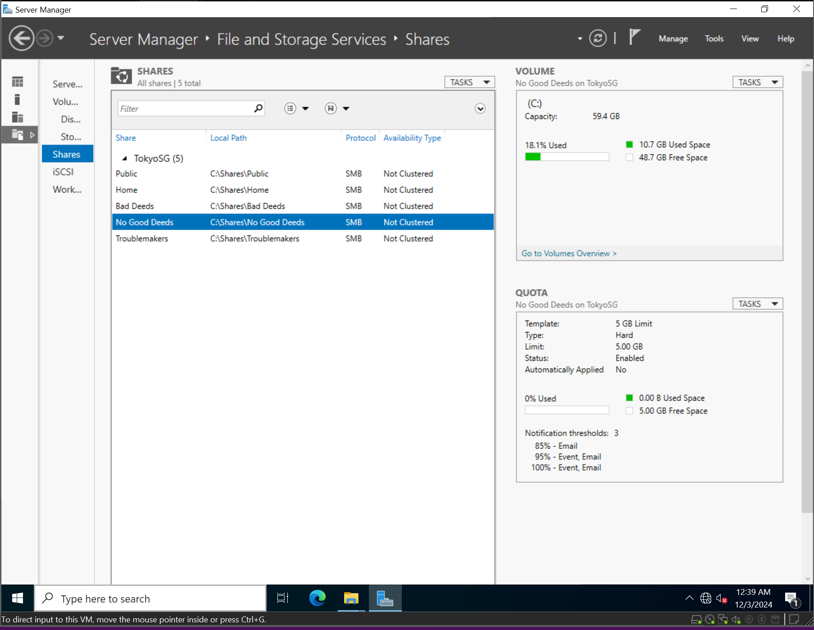  
*No Good Doers storage Quotas*

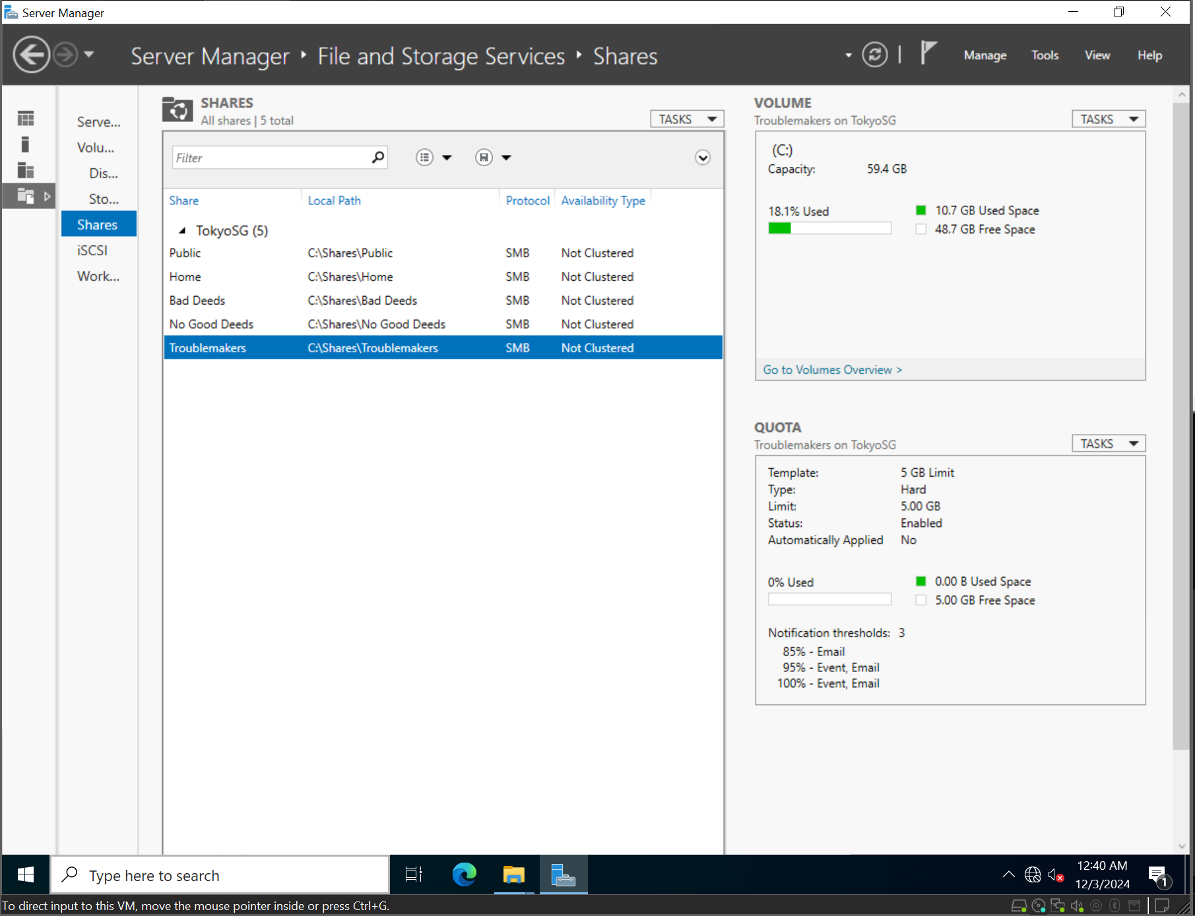  
*Troublemakers storage Quotas*

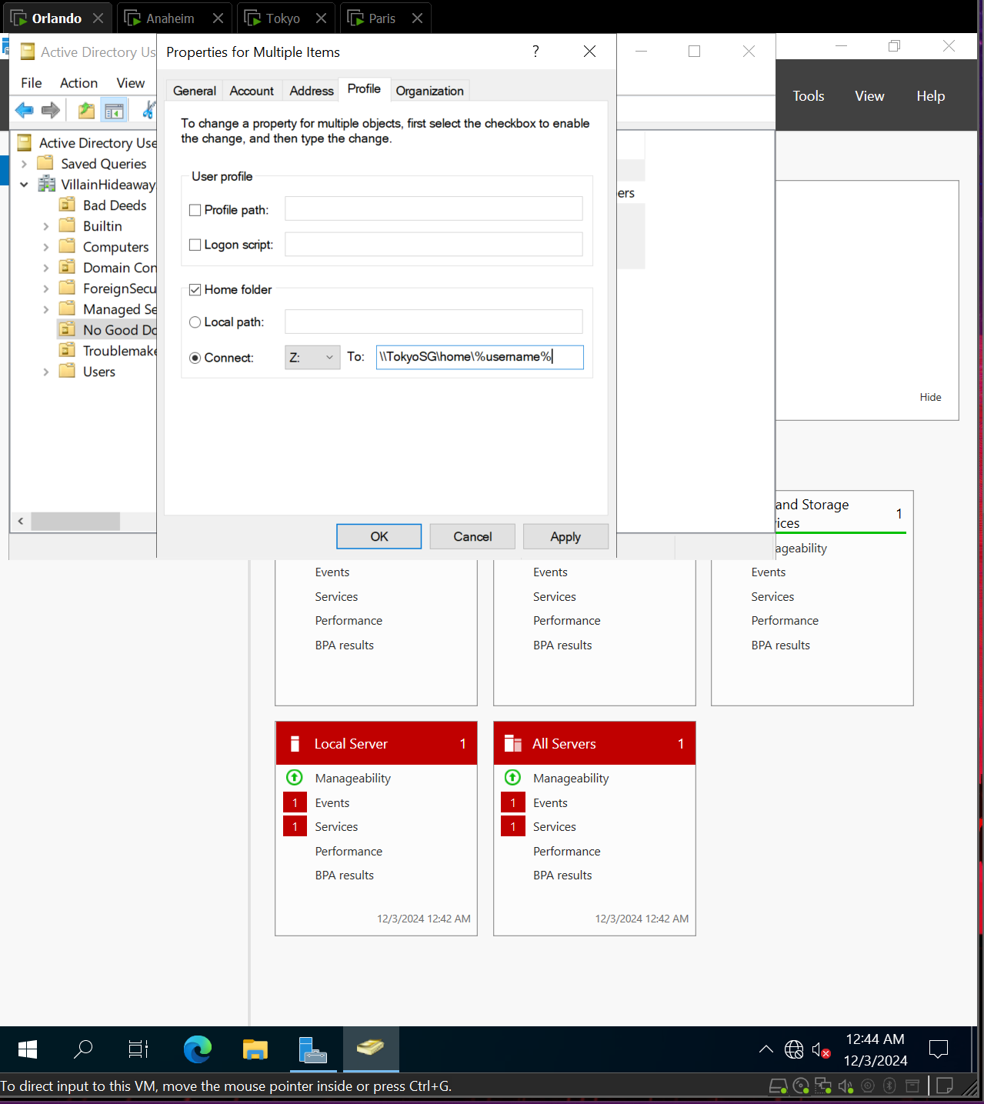  
*Profile settings showing the drive letter AND the path for the shared folder*

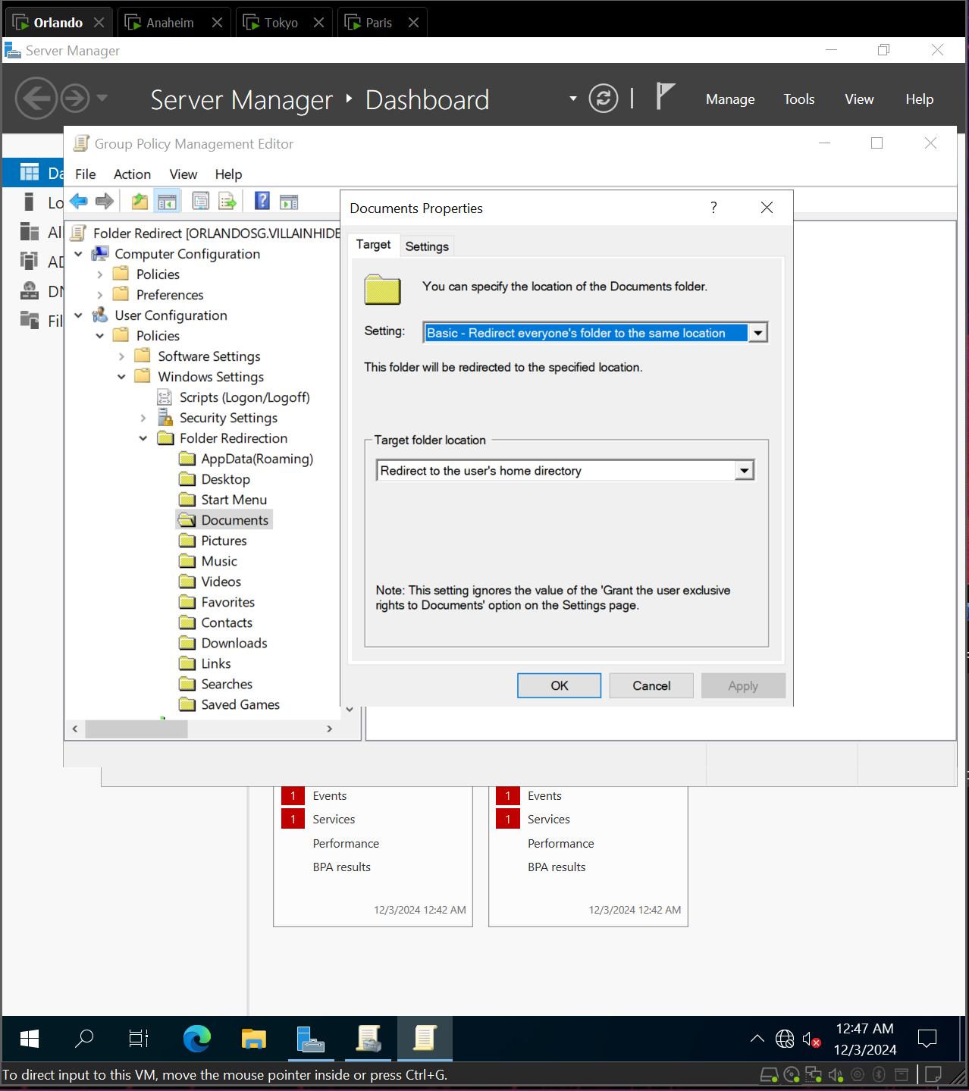 *GPO Setting* *for folder redirection*

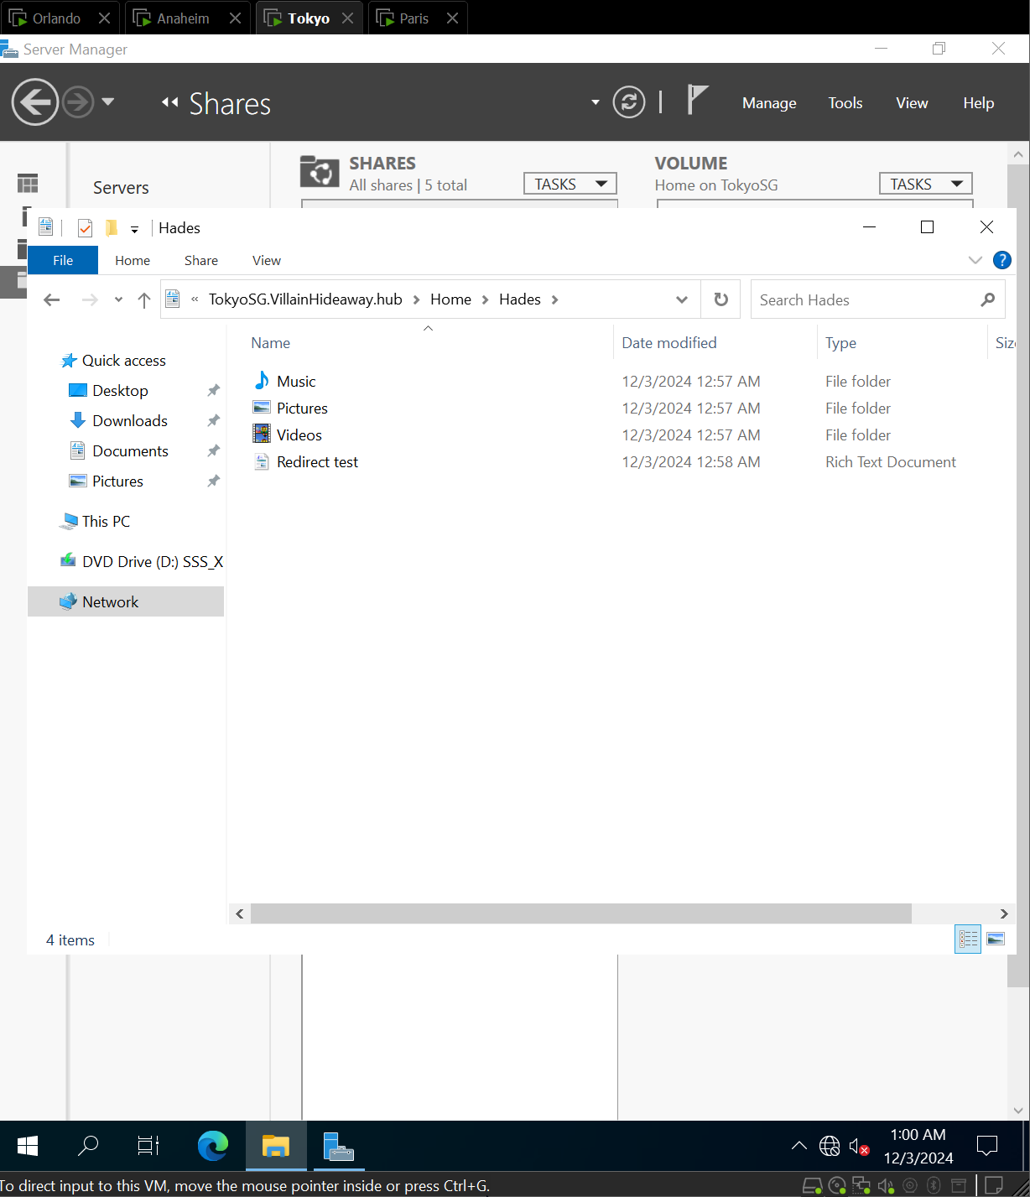  
*Test showing on of the folders being redirected - take a screenshot from the folder in the Shares area of the File Server*

# OU/Groups/Users Screenshots

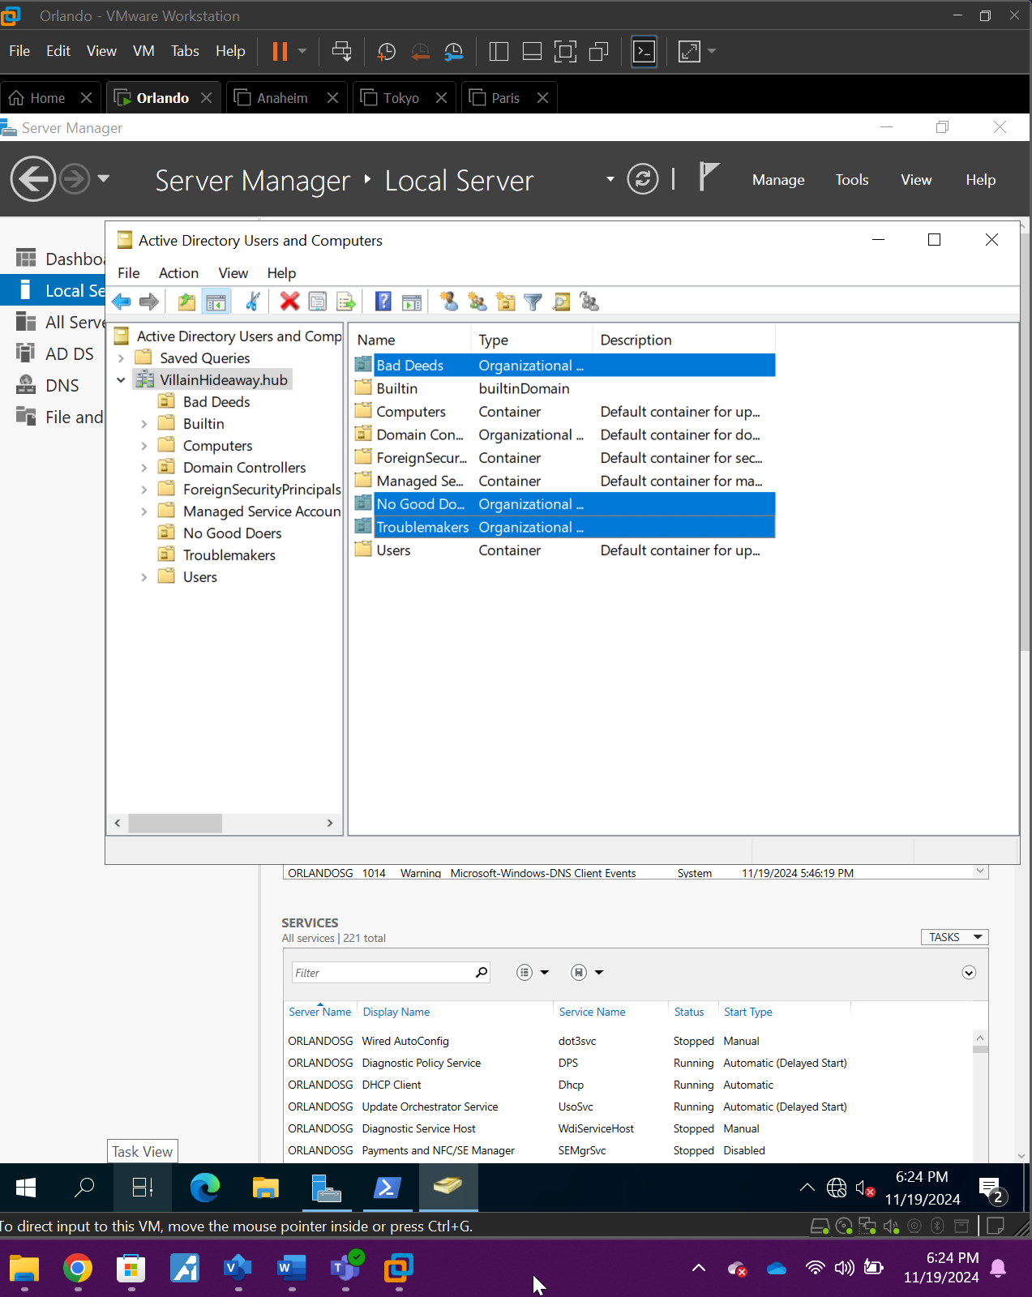Three Created OU’s (Bad Deeds, No Good Doers, Troublemakers)

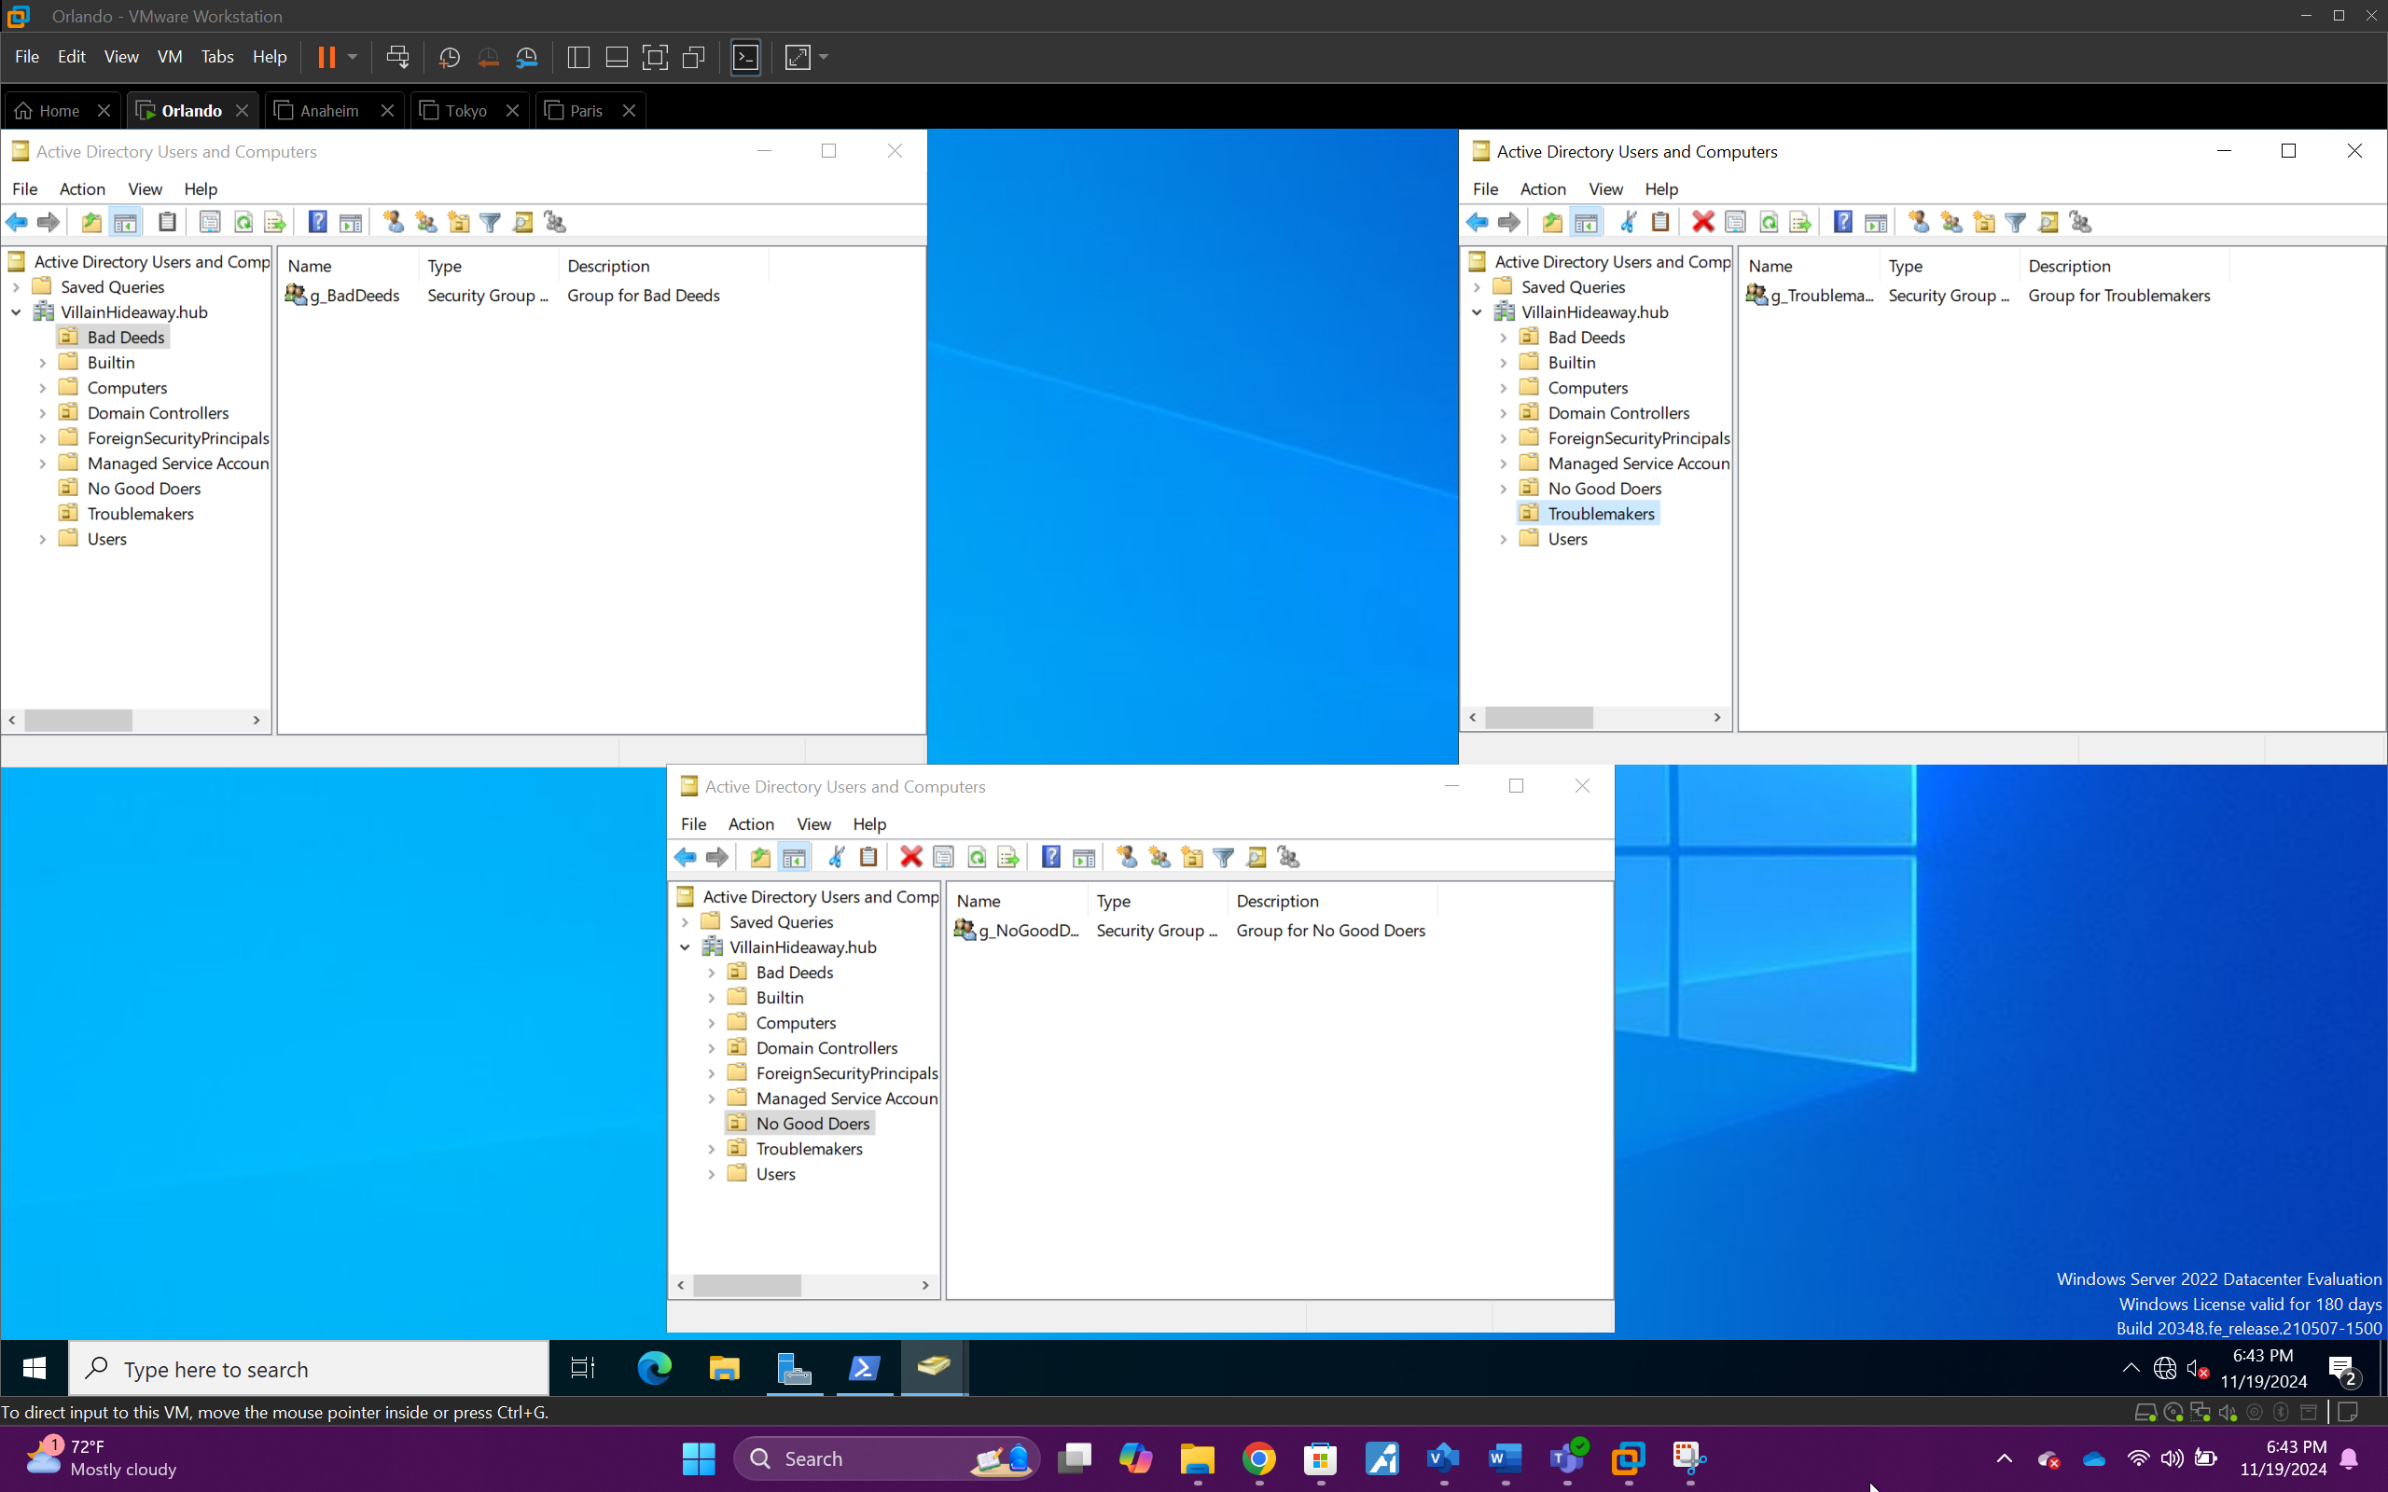Three OU’s With their added groups (g_BadDeeds, g_NoGoodDoers, g_Troublemakers)

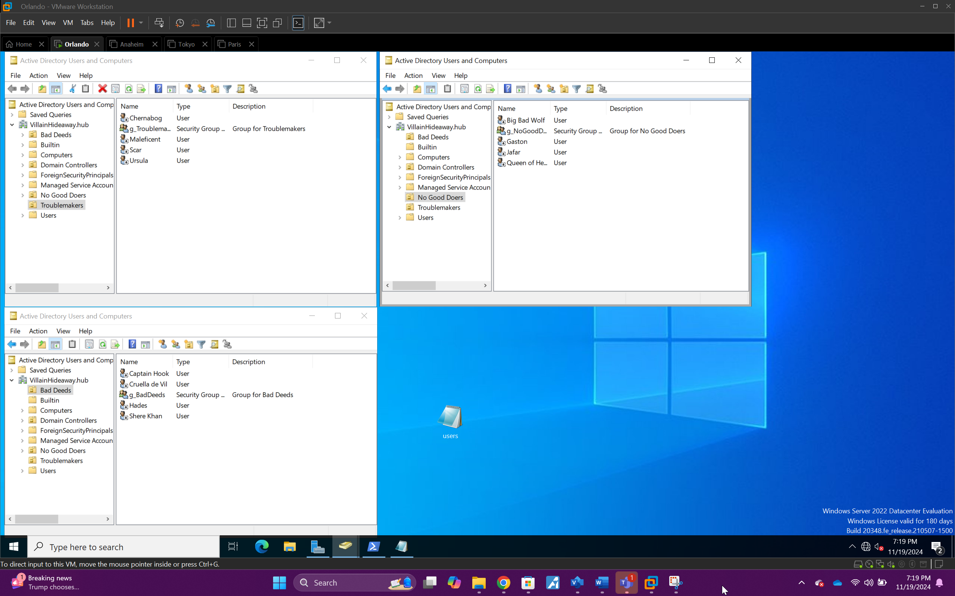All twelve users added into their Groups and OU’s

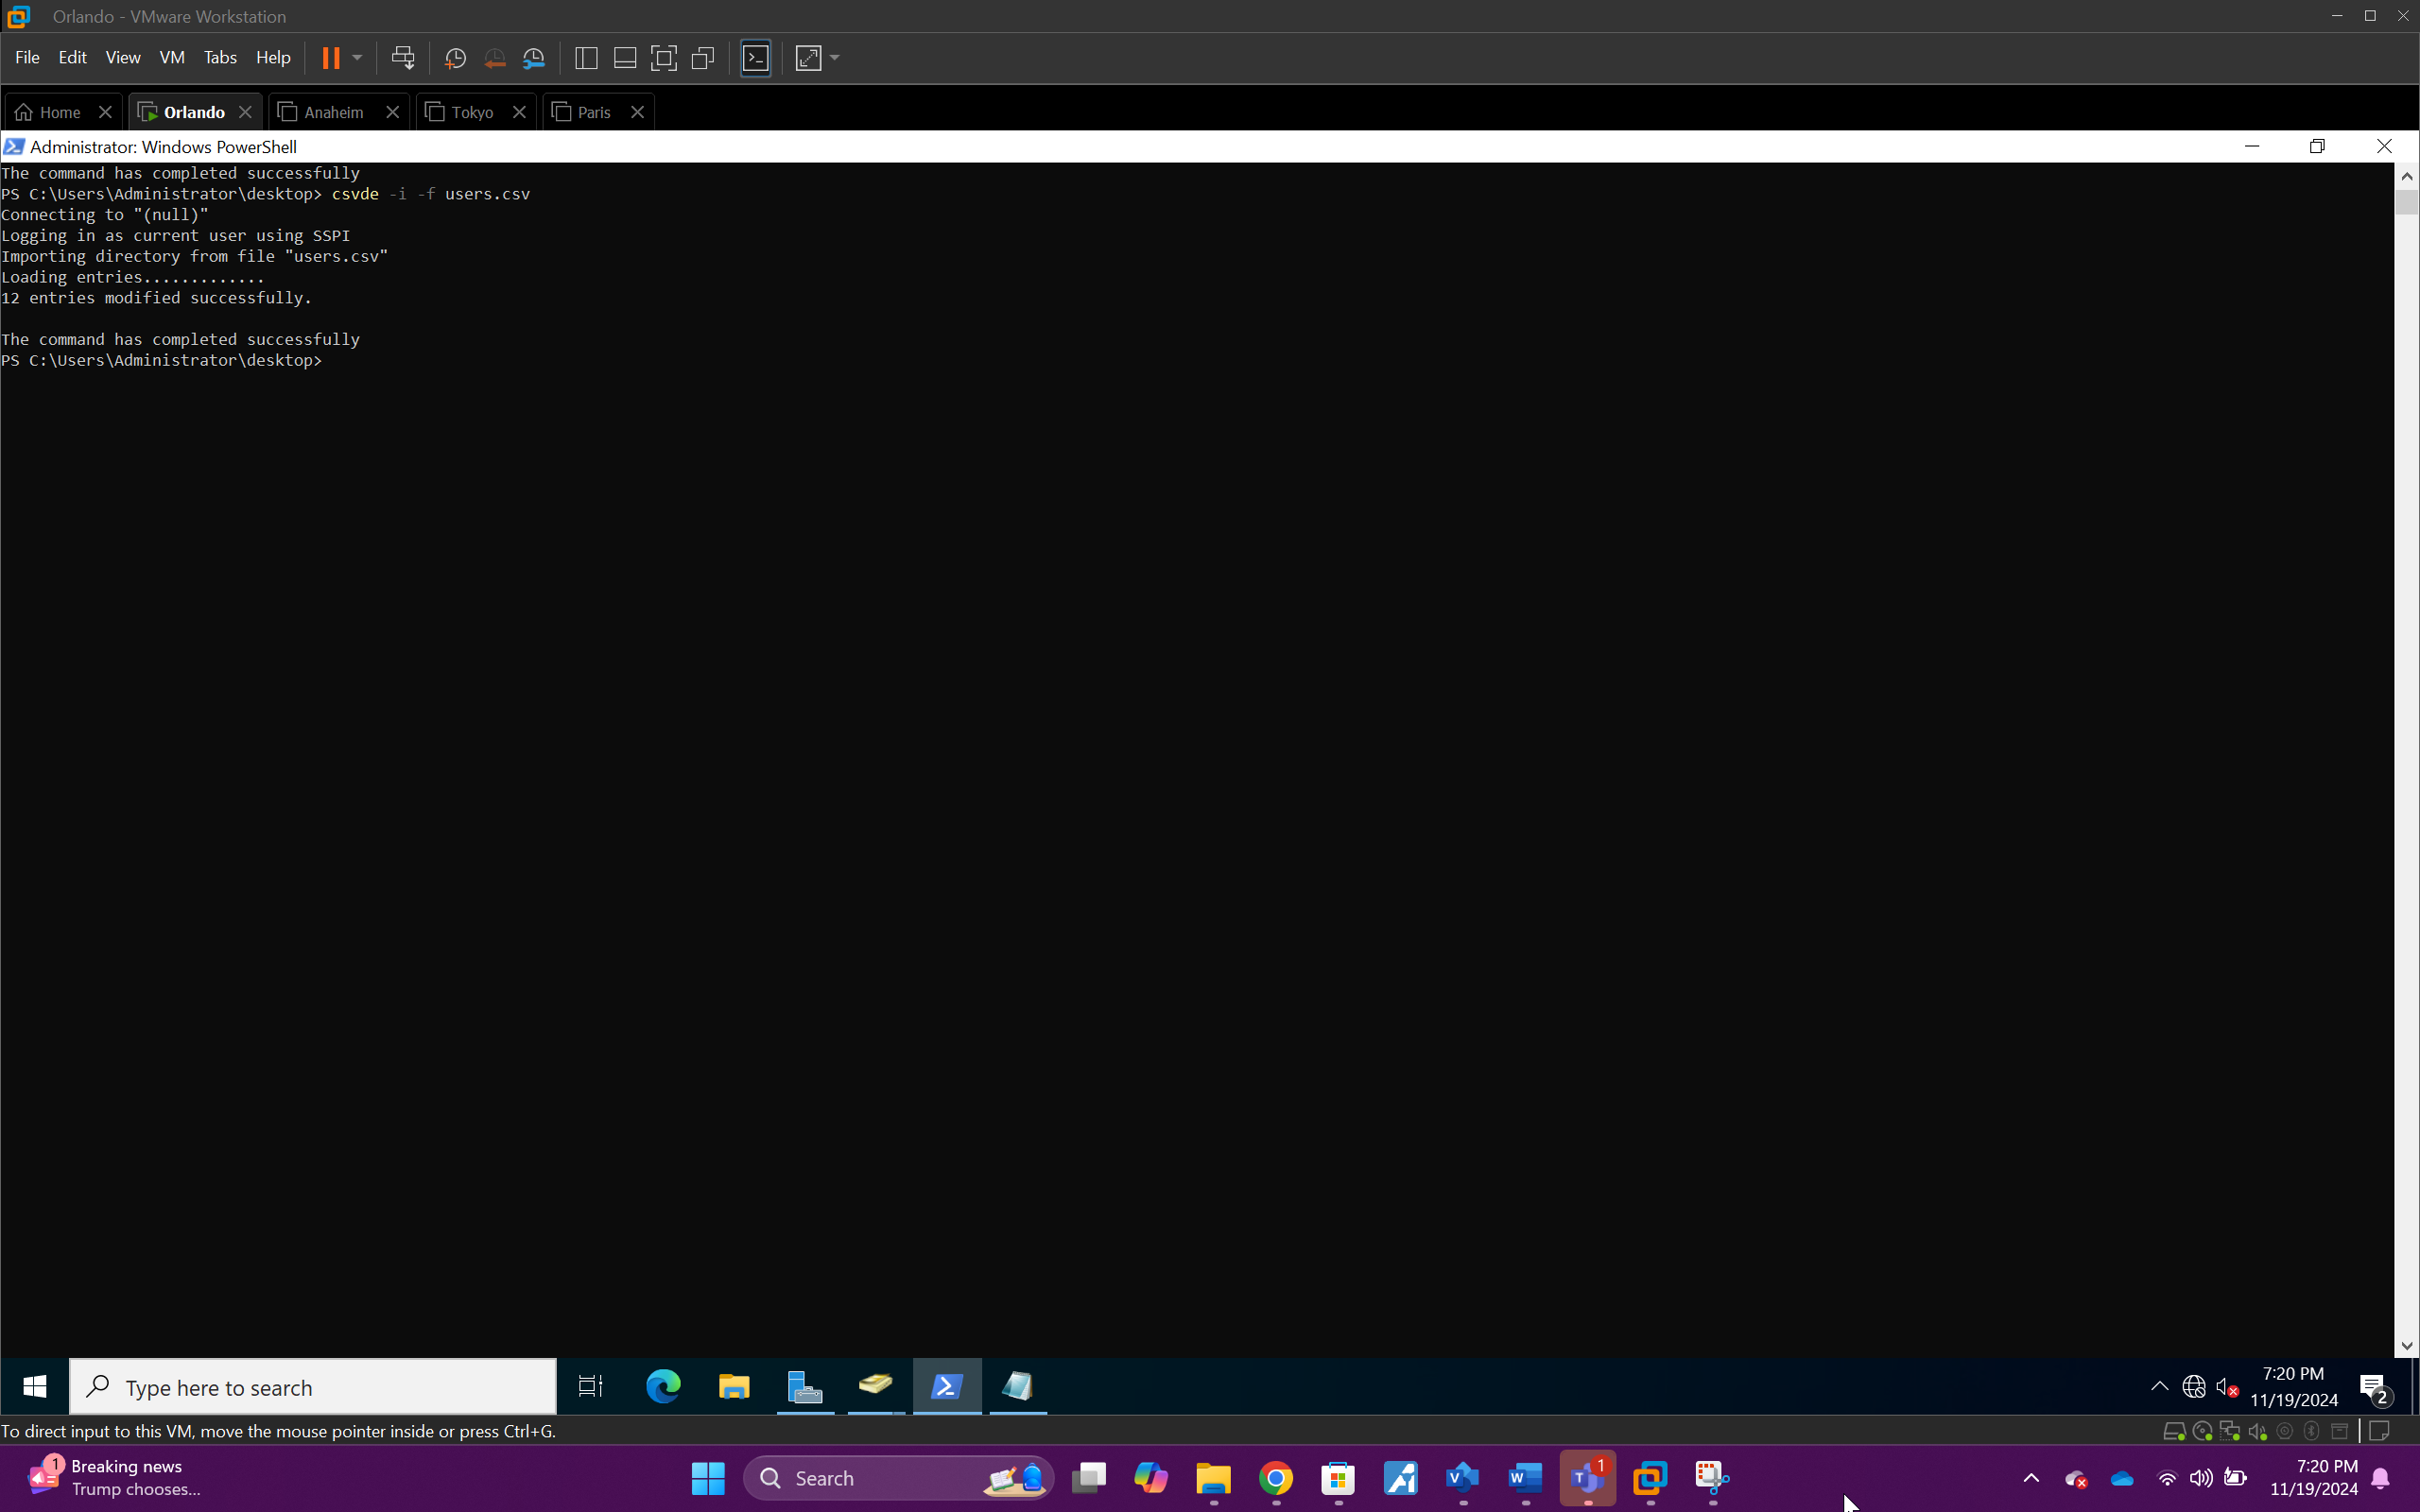CSV command used to add the users via powershell

Client Documentation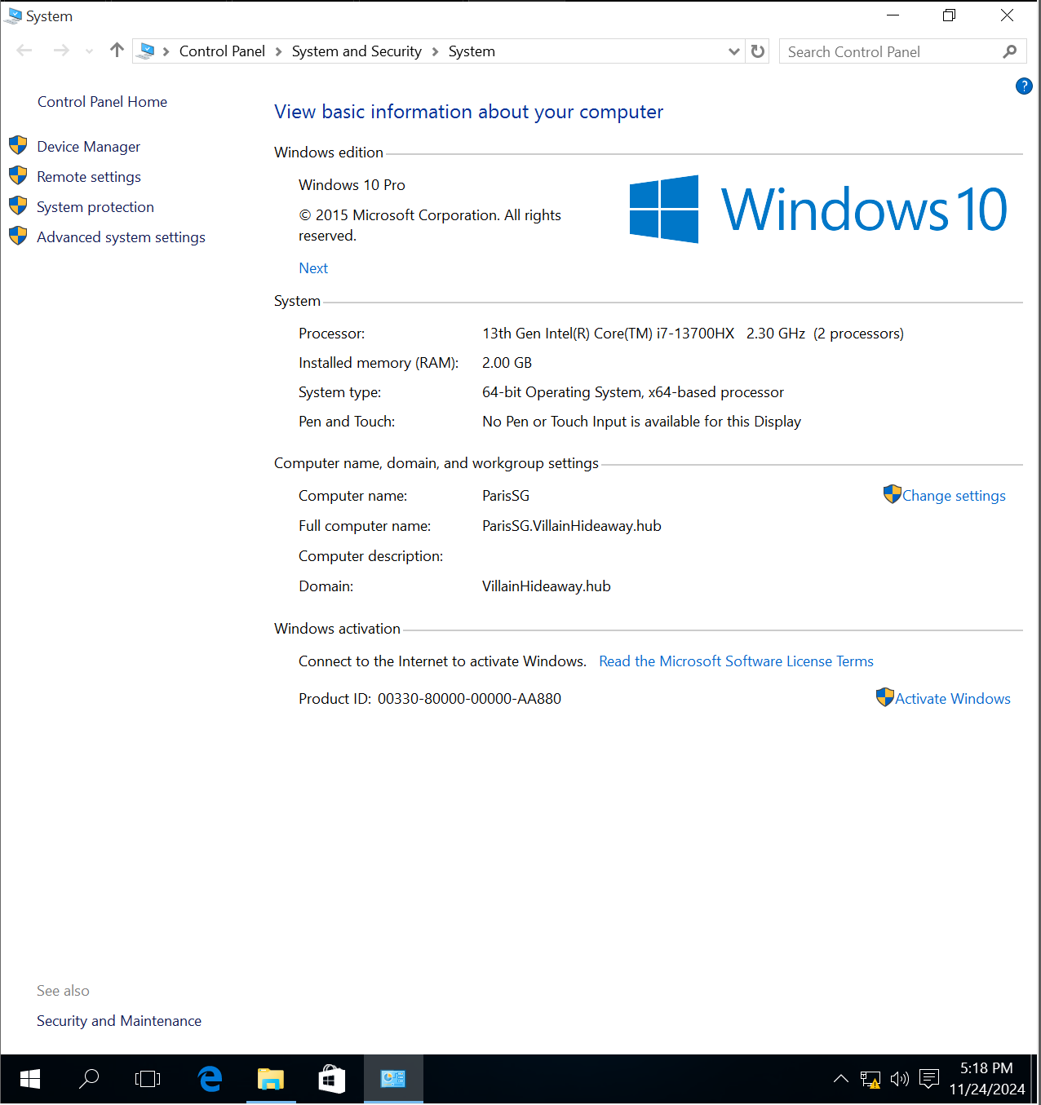Client (ParisSG) – System Information

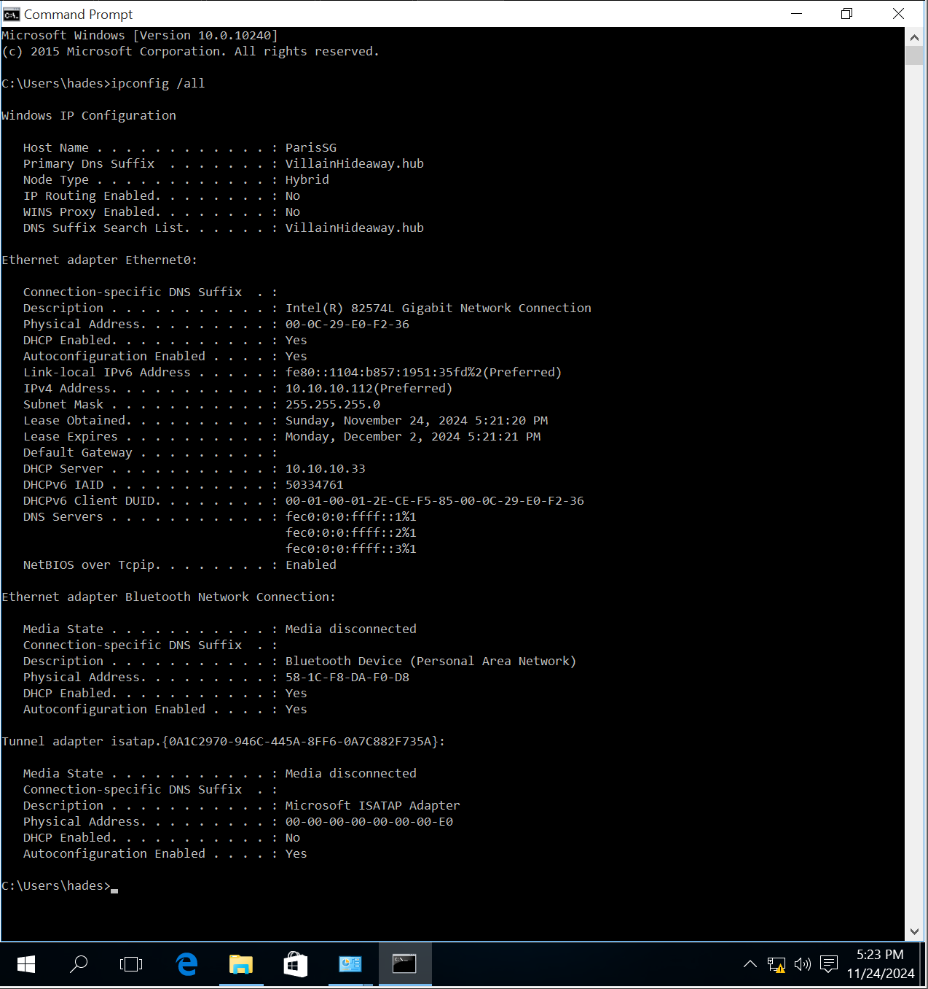*Client ParisSG Joined w/ IP*

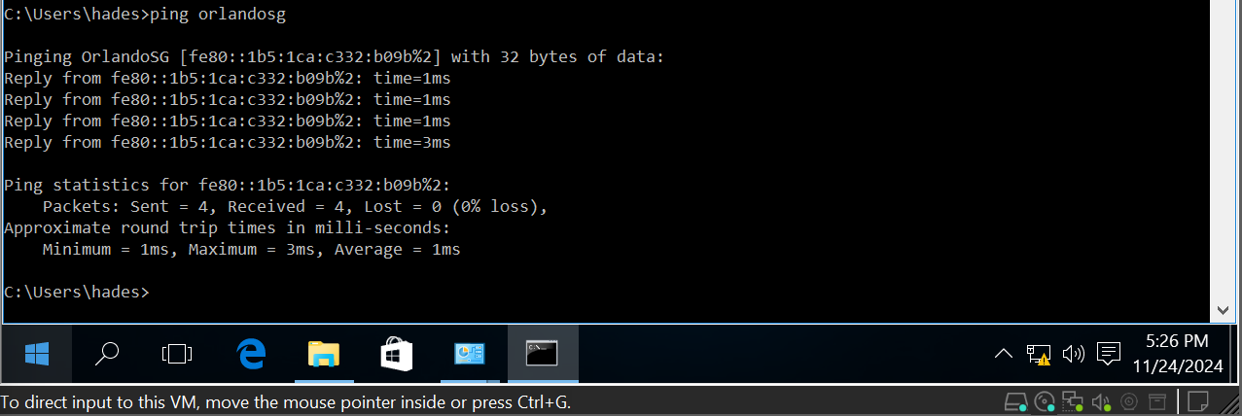  
*Client Paris – Ping to DC (Orlando)*

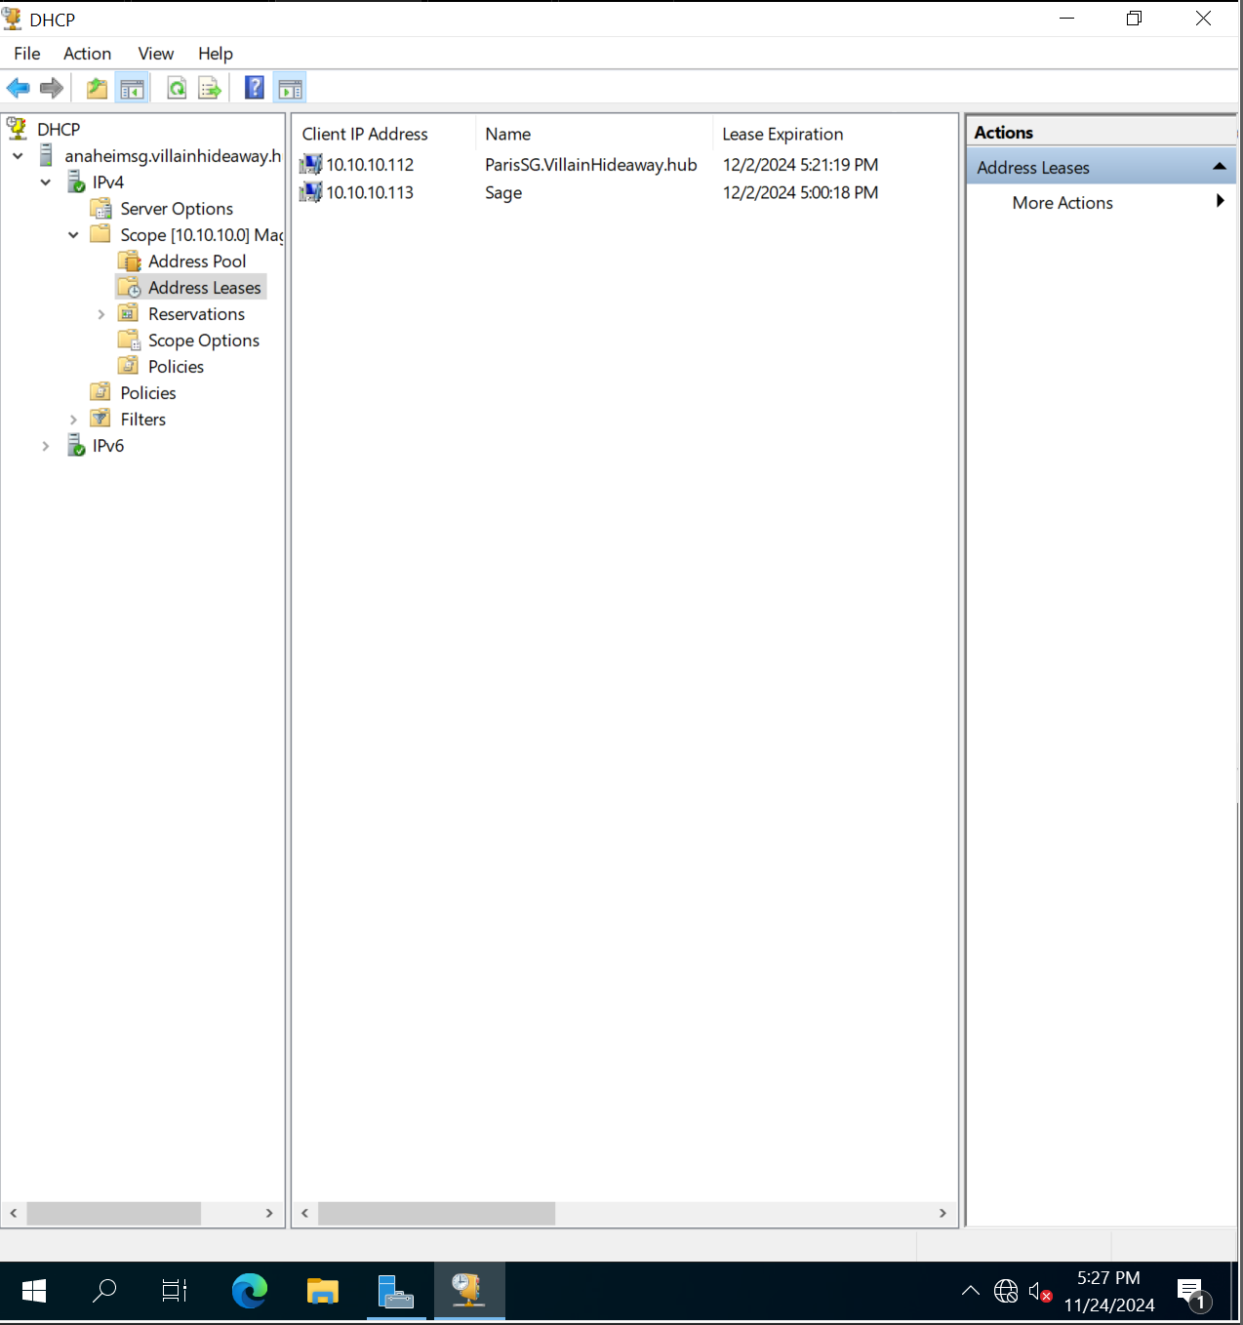  
*Screenshot from the DHCP console on Server 2 showing the client in the address leases*

# Group Policy Documentation

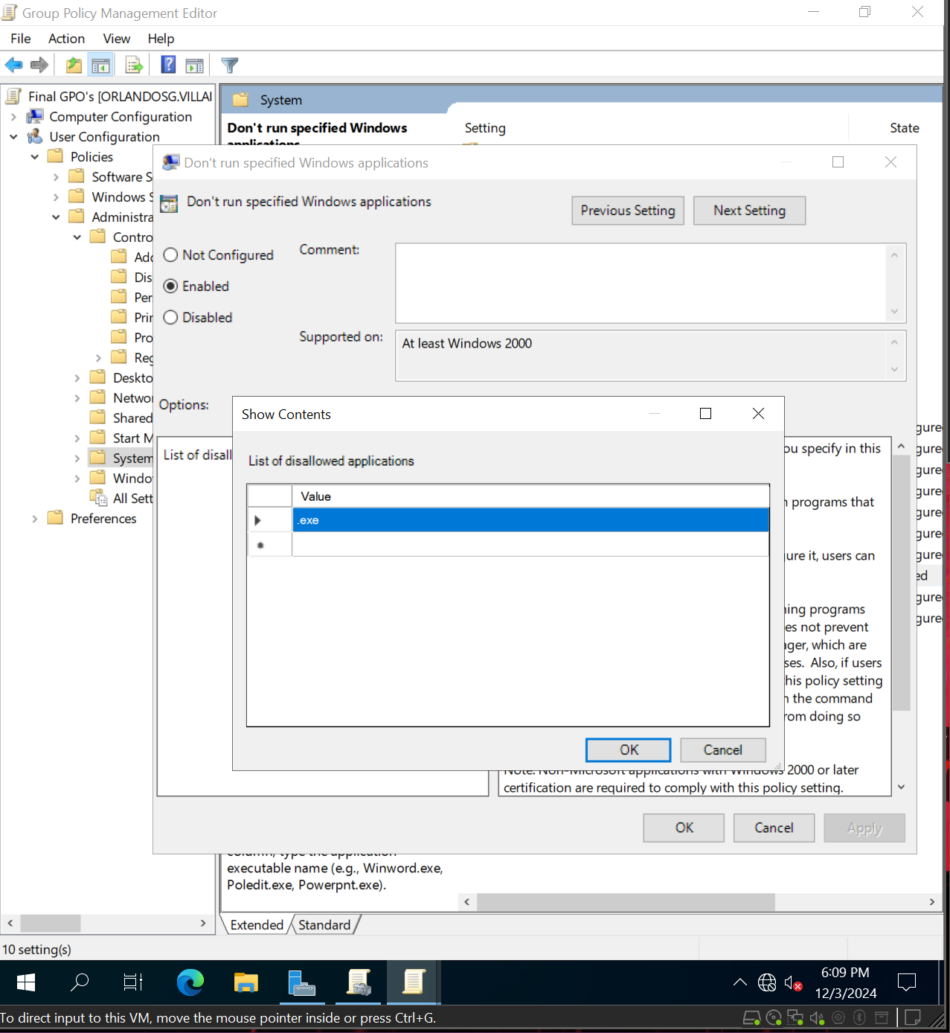  
*Do not allow the user to load a program (install or run an .exe)*

*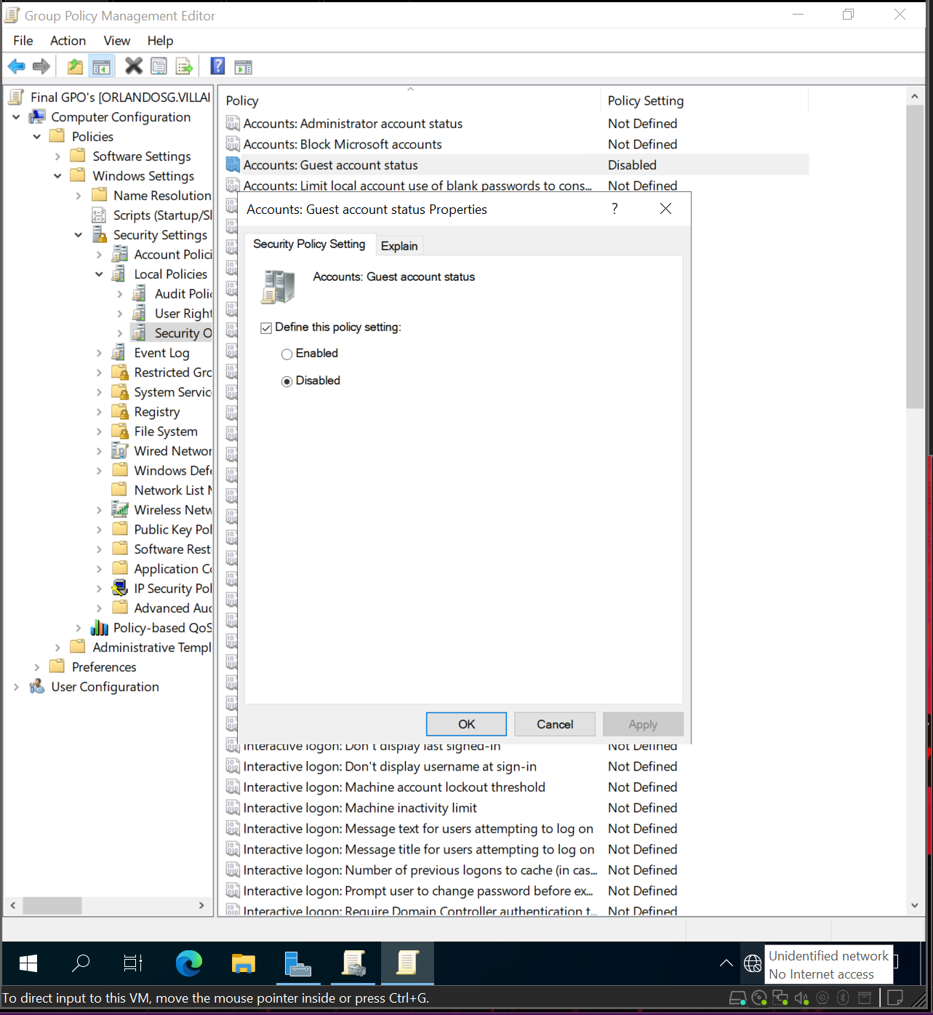  
Disable the guest account*

*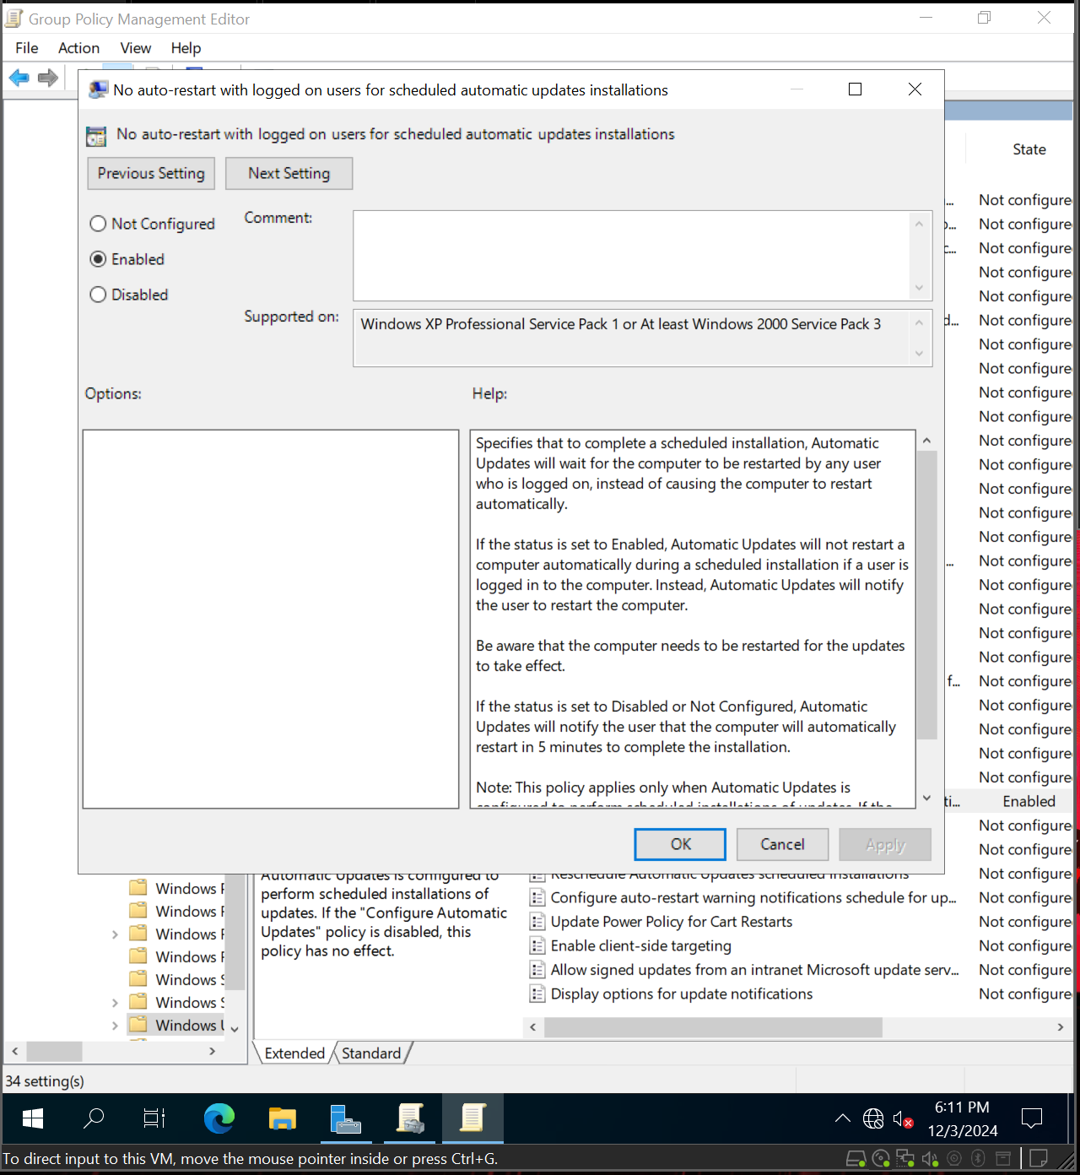  
Disable forced system restarts*

*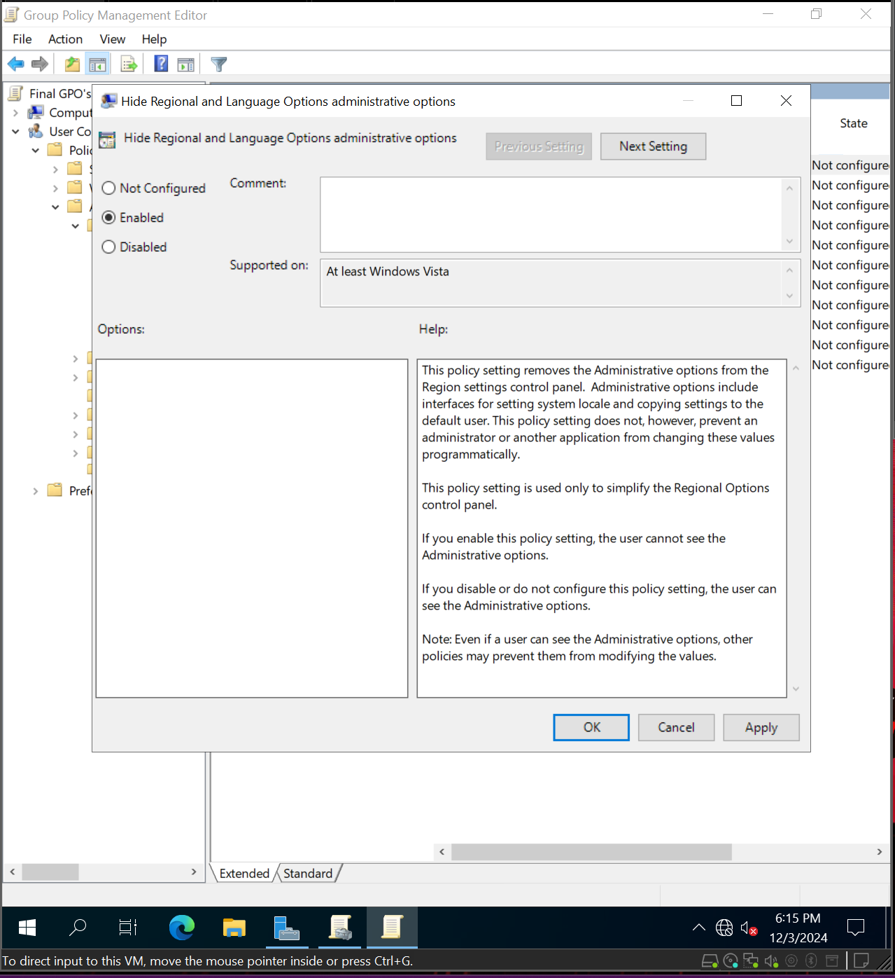  
Prevent users from changing the time, though allow them to view the calendar*

*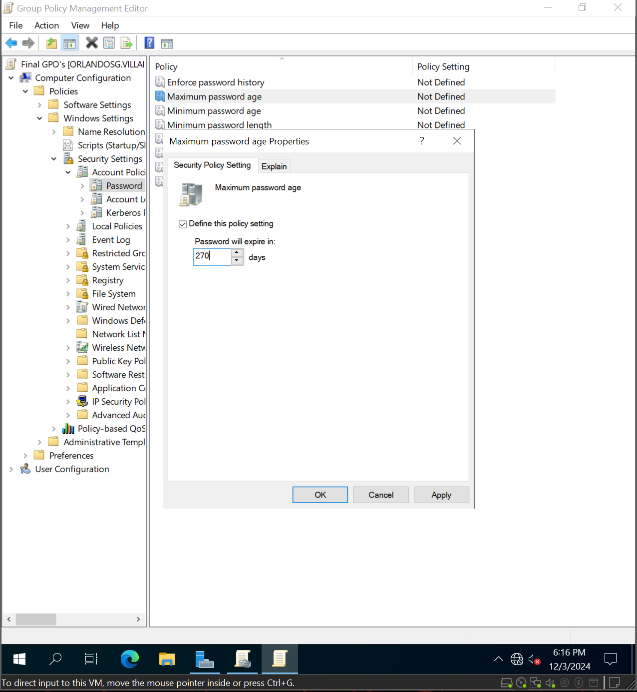  
Set password expiration to 270 days*

*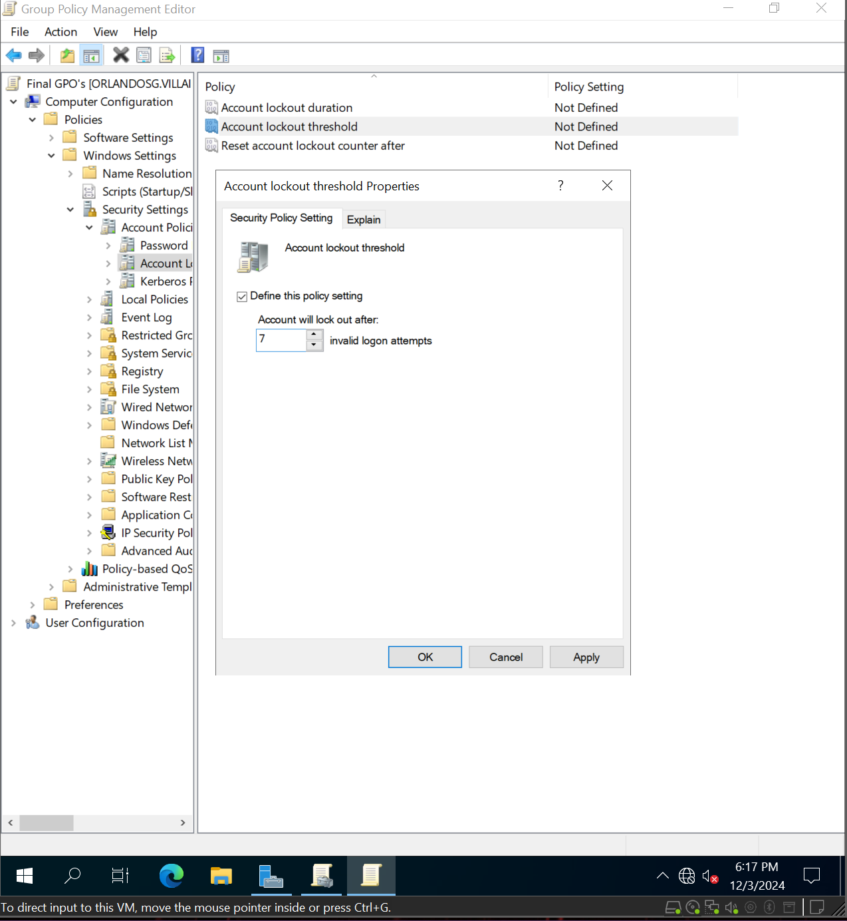  
Allow users seven attempts before locking their account*

*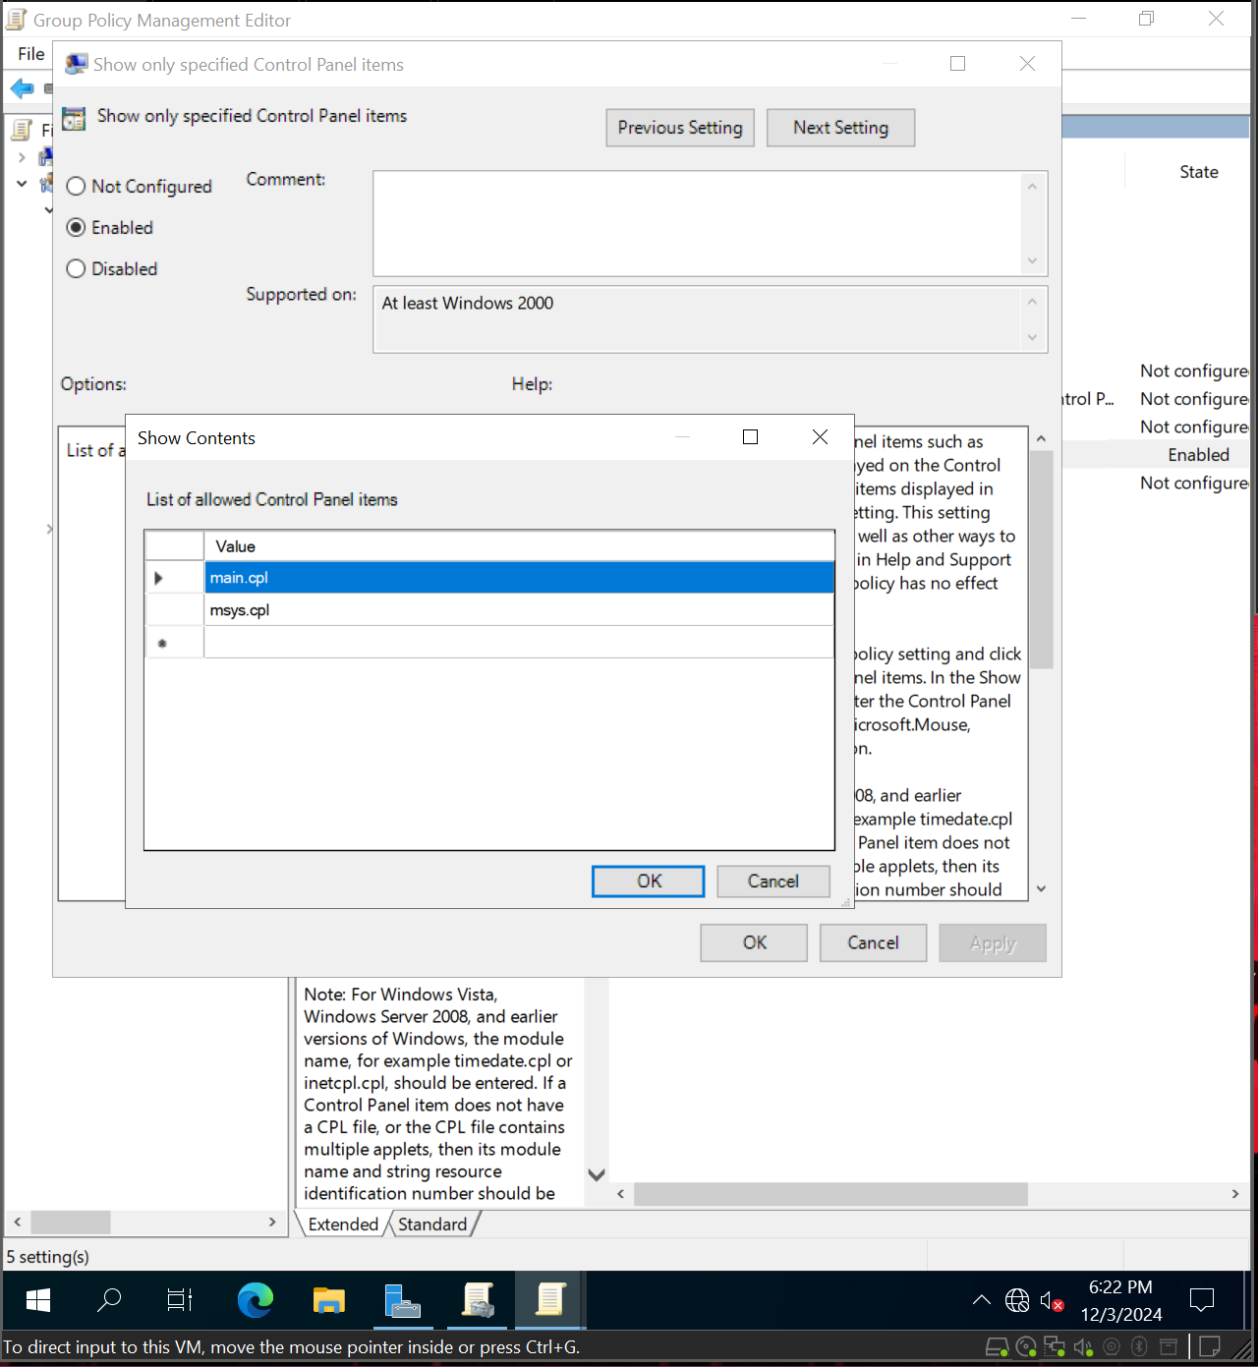  
Allow user access to keyboard and mouse but no other control panel application*

*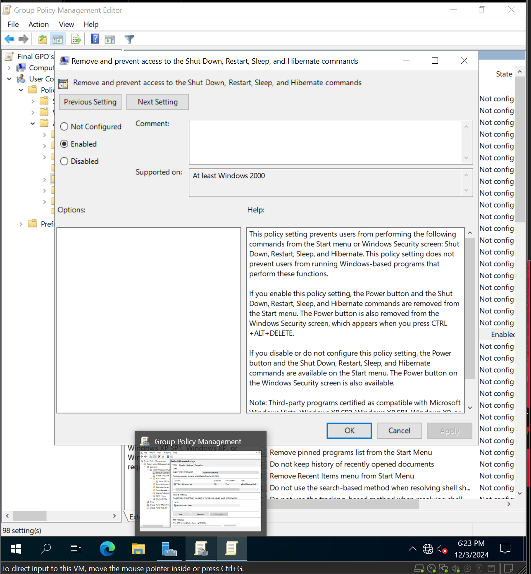  
Do not allow users to shut down the system*

*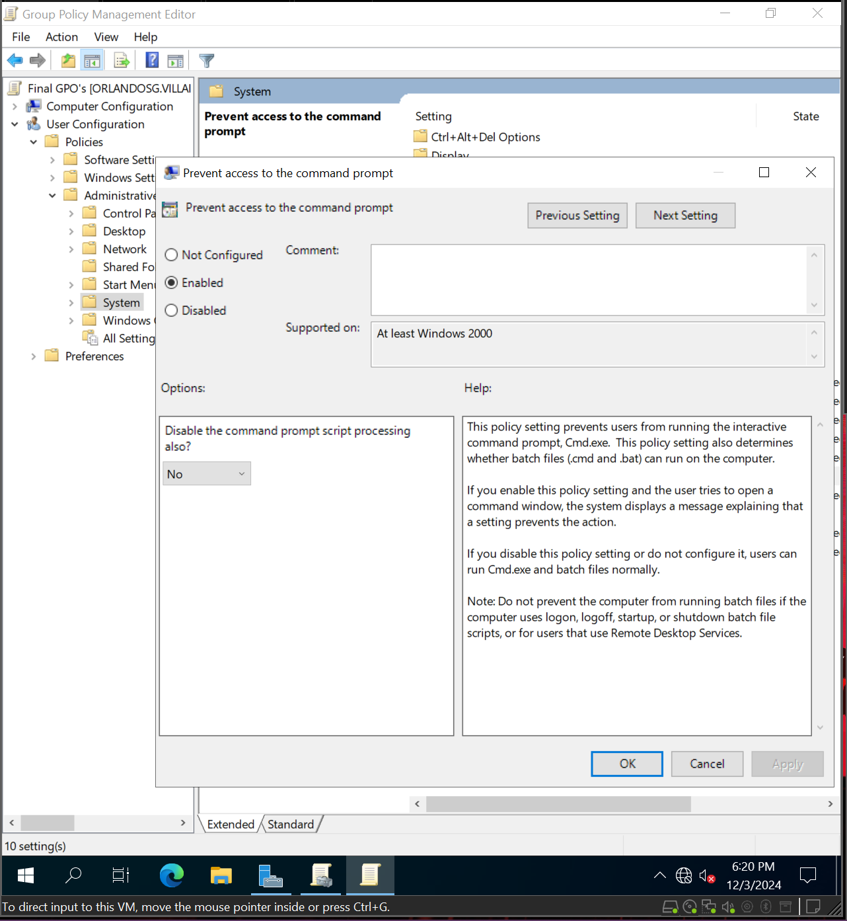  
Remove the ability to use the command prompt*

*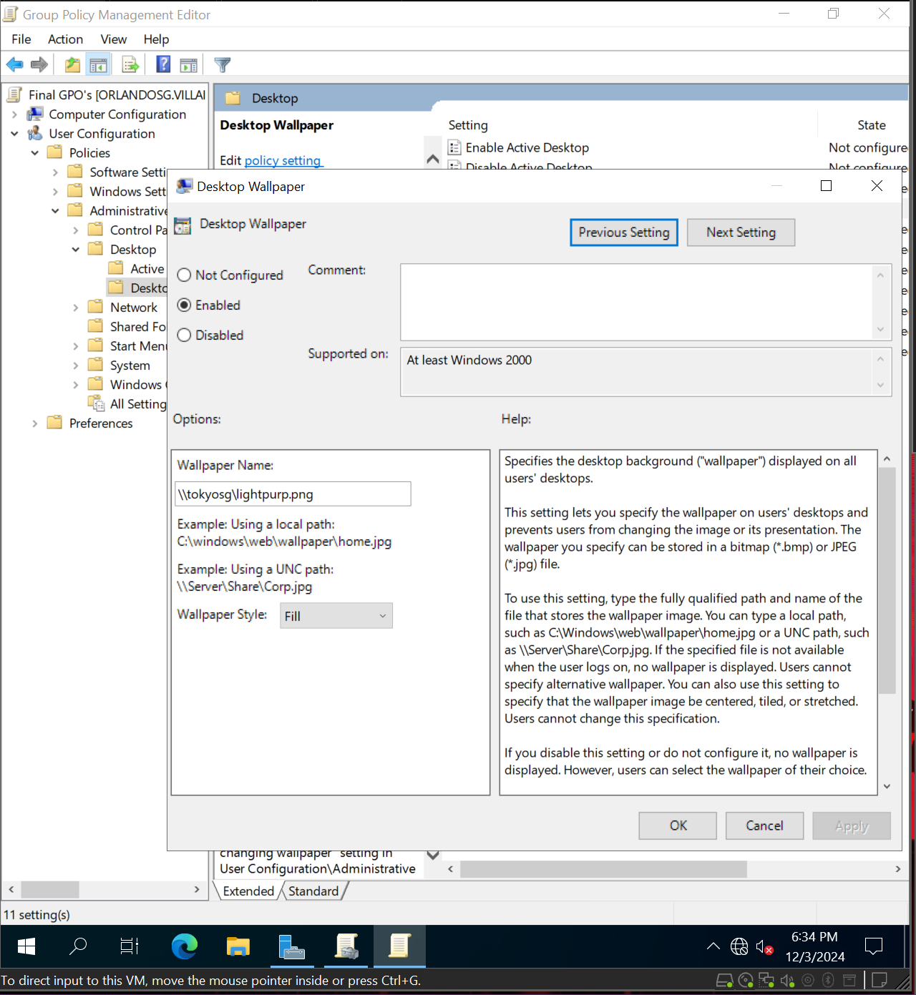  
Change the default background of all computers to Light Purple (rgb(212, 142, 207))*

*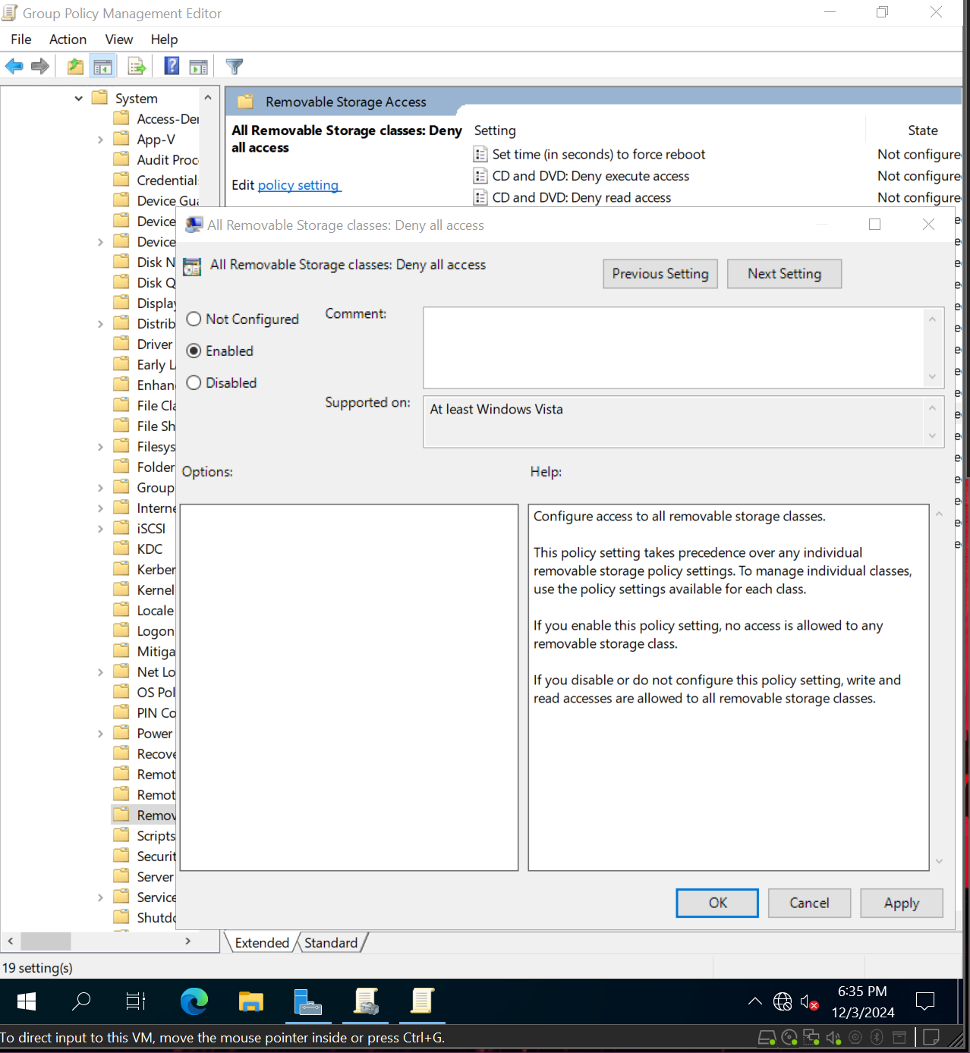  
Disable USB devices*

*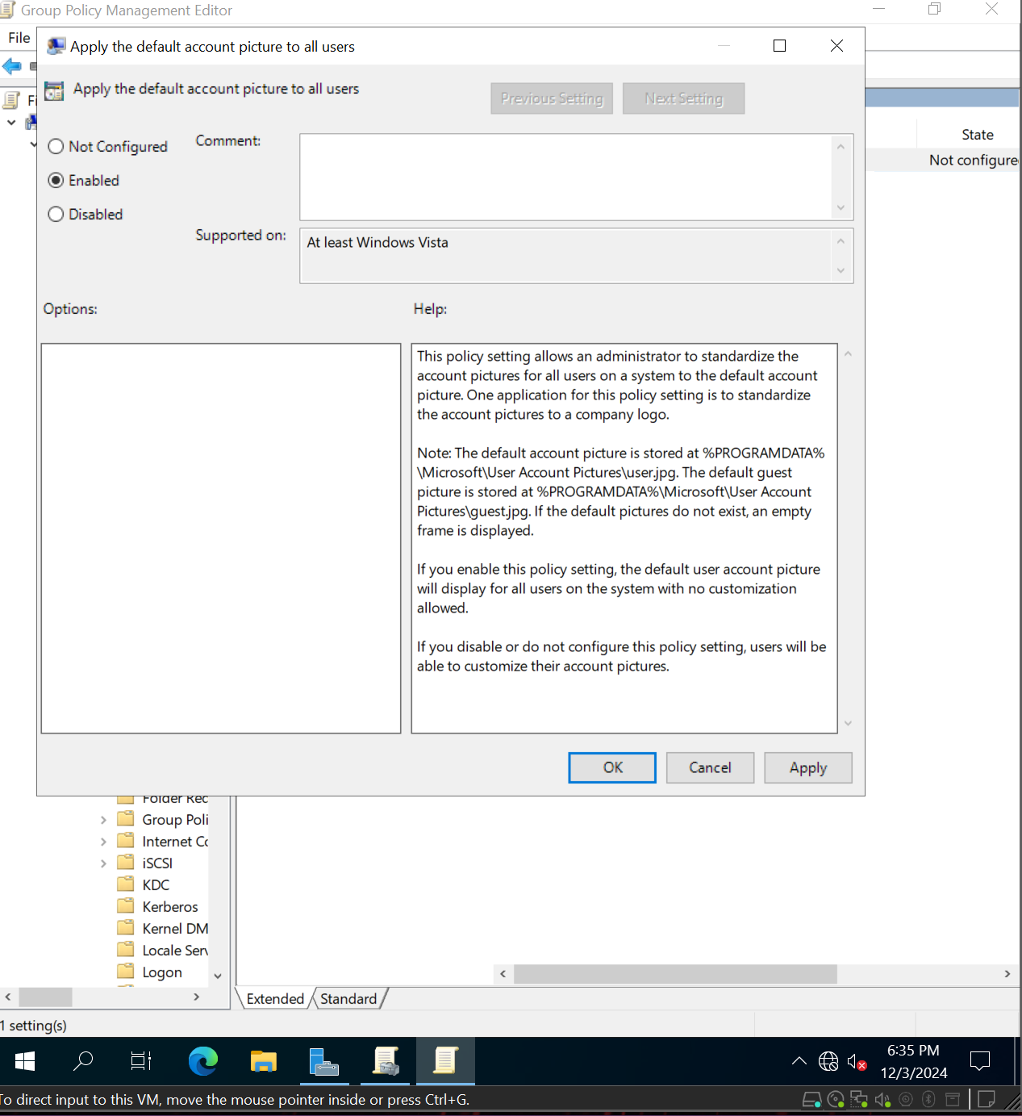  
Apply the default account picture to all users*

*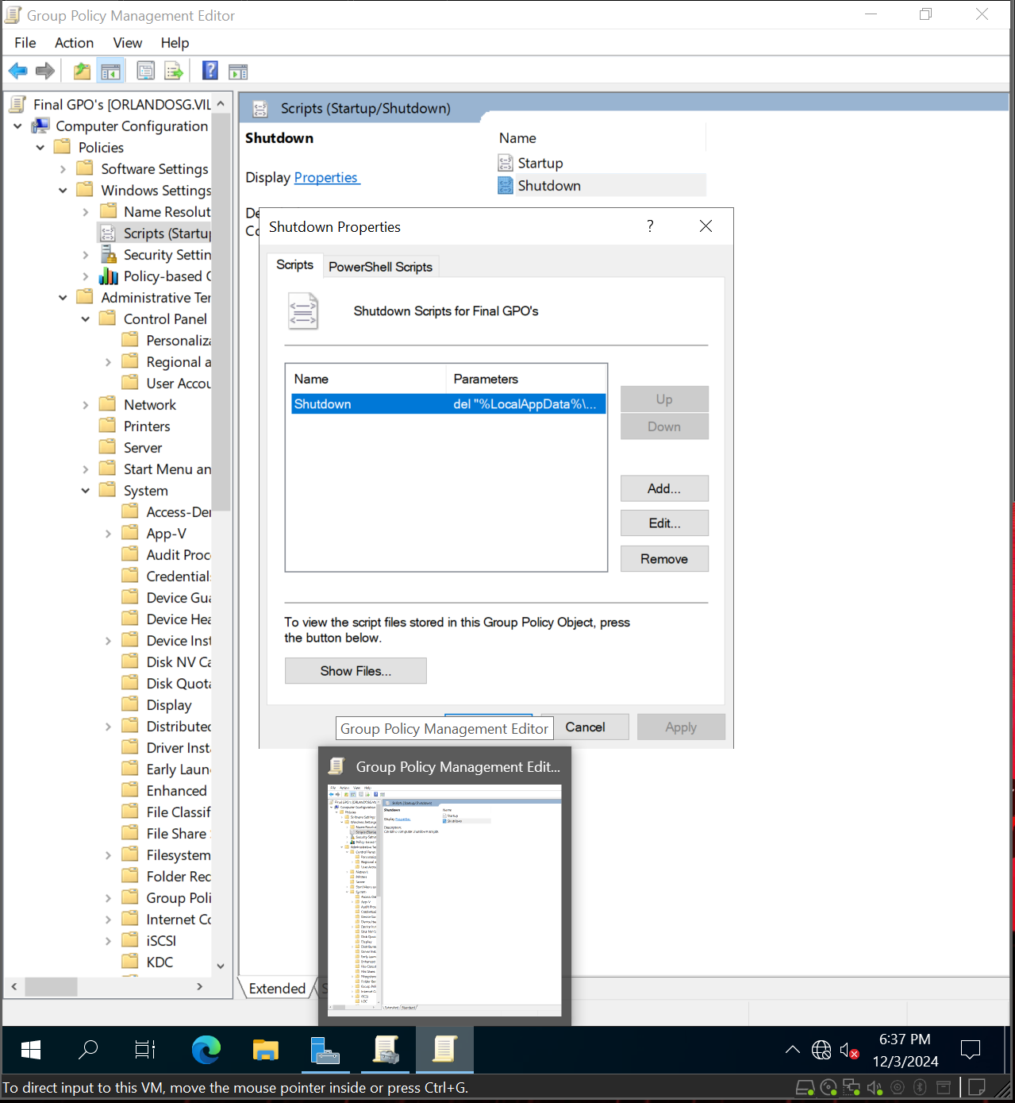  
Create a startup script that deletes the contents of the "%LocalAppData%\Microsoft\Edge\User Data\Default\cookies" folder on shutdown*

*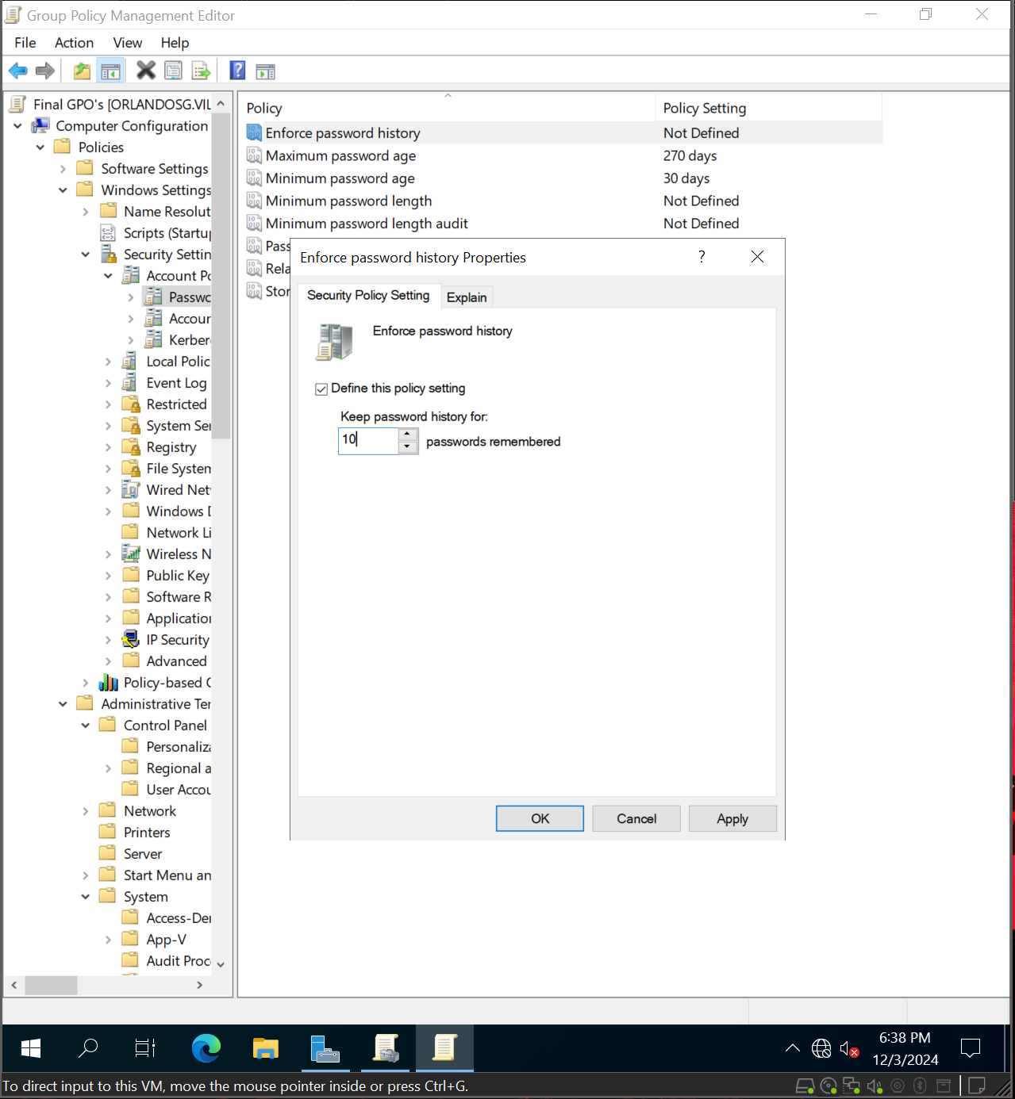  
Set password history to 10*

*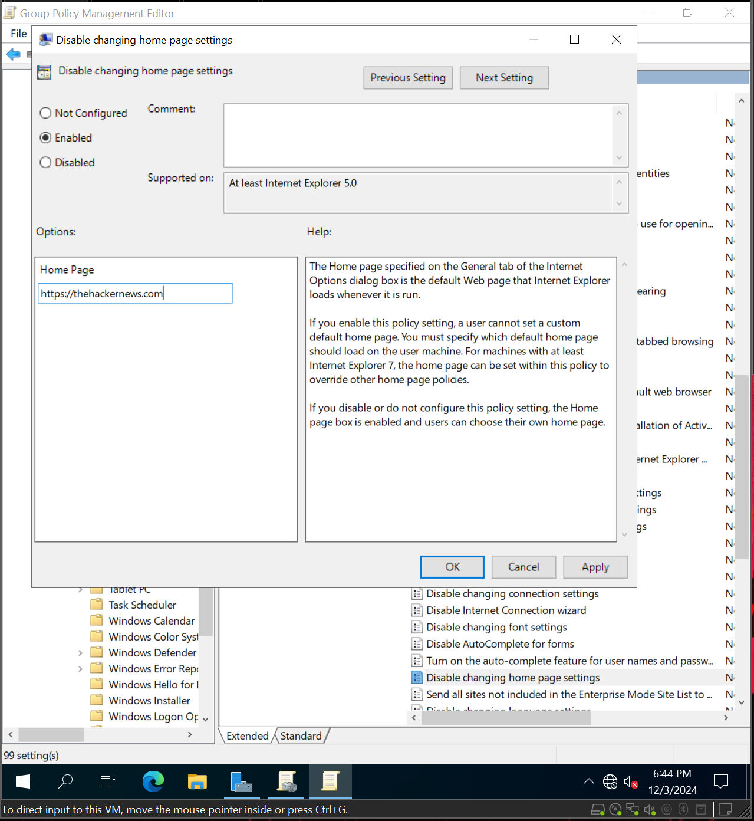  
Set the default webpage to*[*https://thehackernews.com/Links to an external site.*](https://thehackernews.com/)

*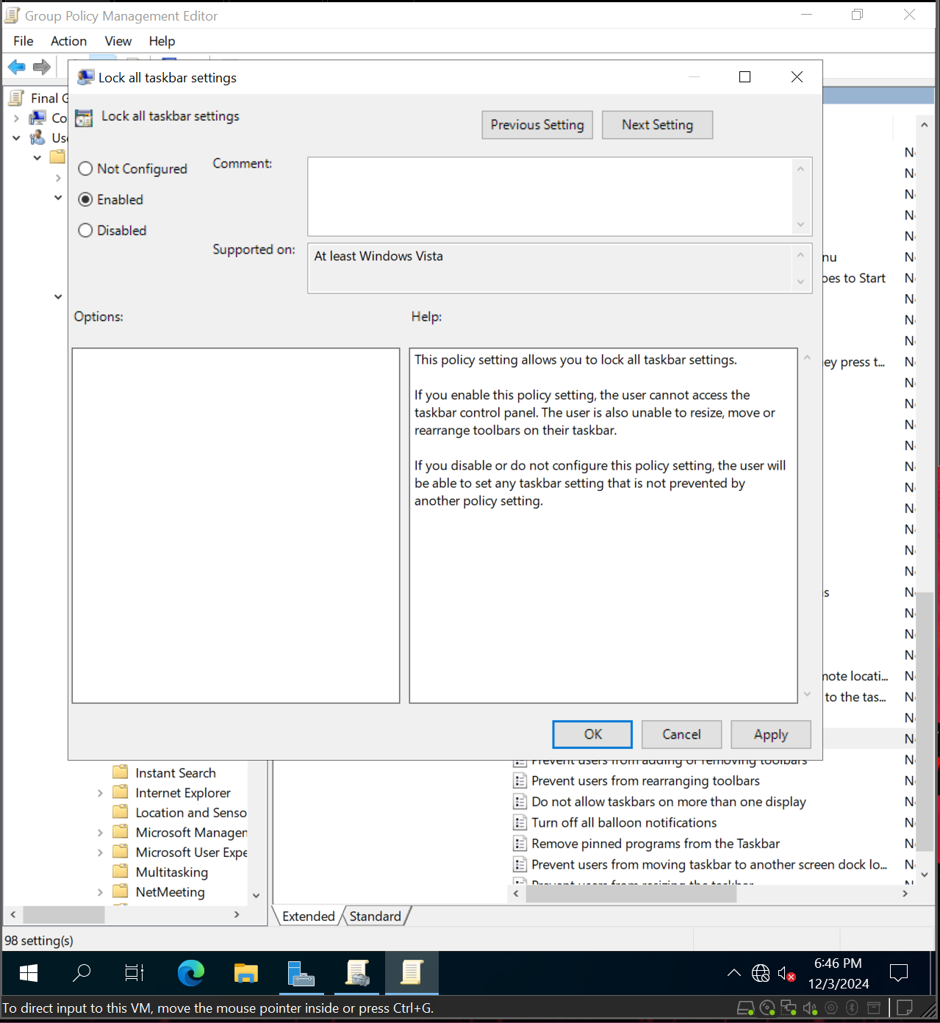  
Lock the taskbar so users cannot change its location*

*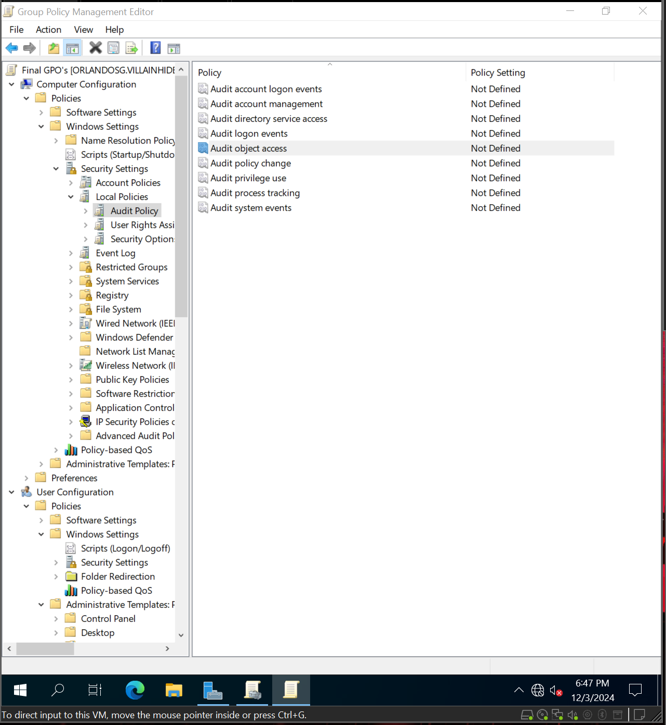  
Audit object Access for Failure*

*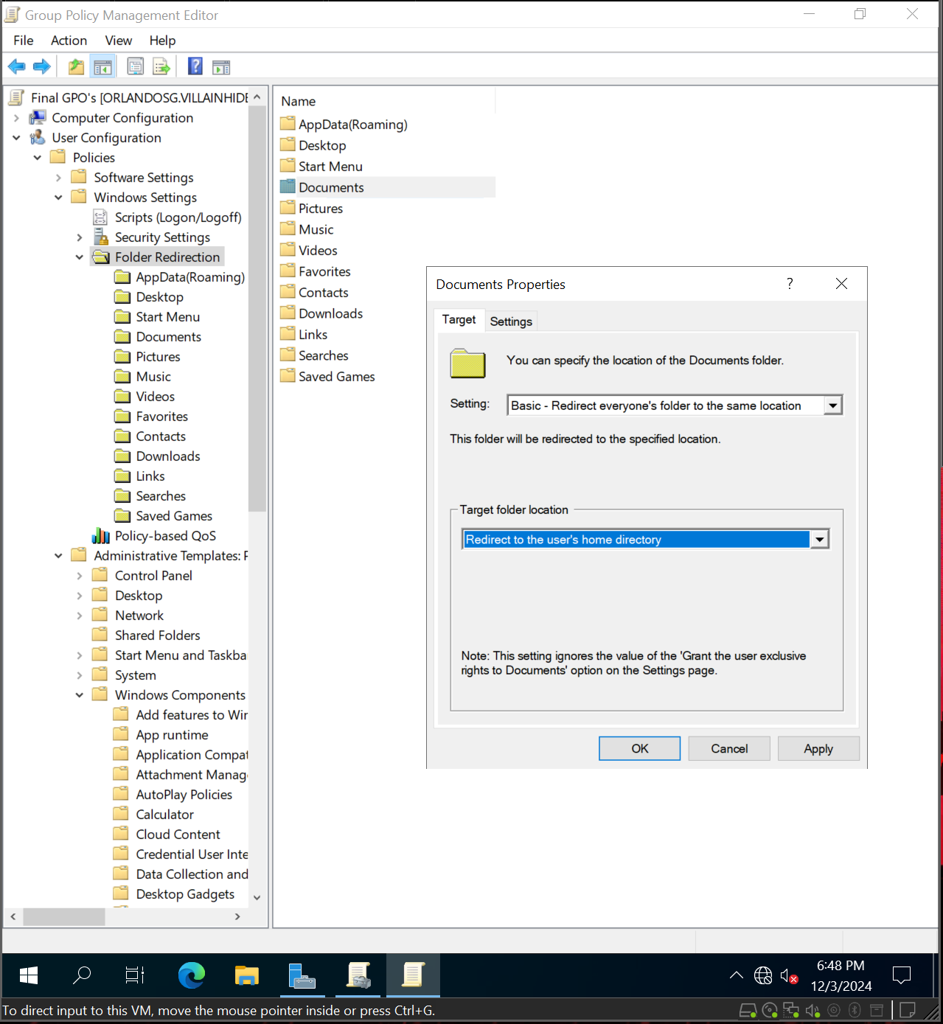  
Redirect the documents folder to the File server [from previous assignment]*

*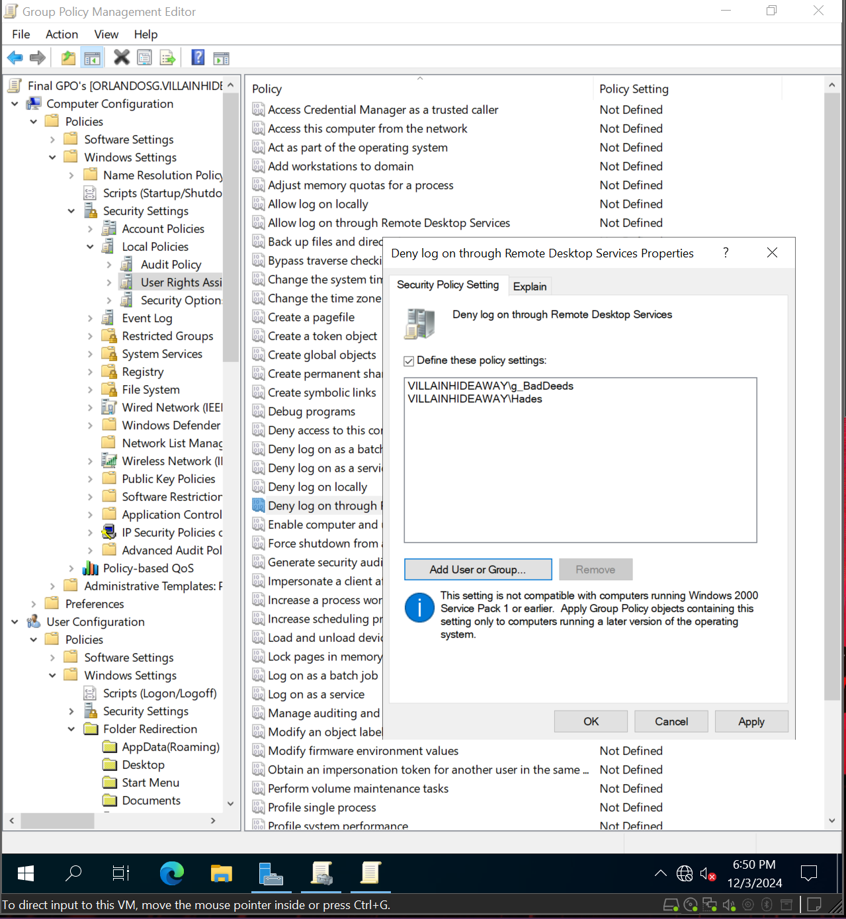  
Deny log on through remote desktop services (RDS)*

*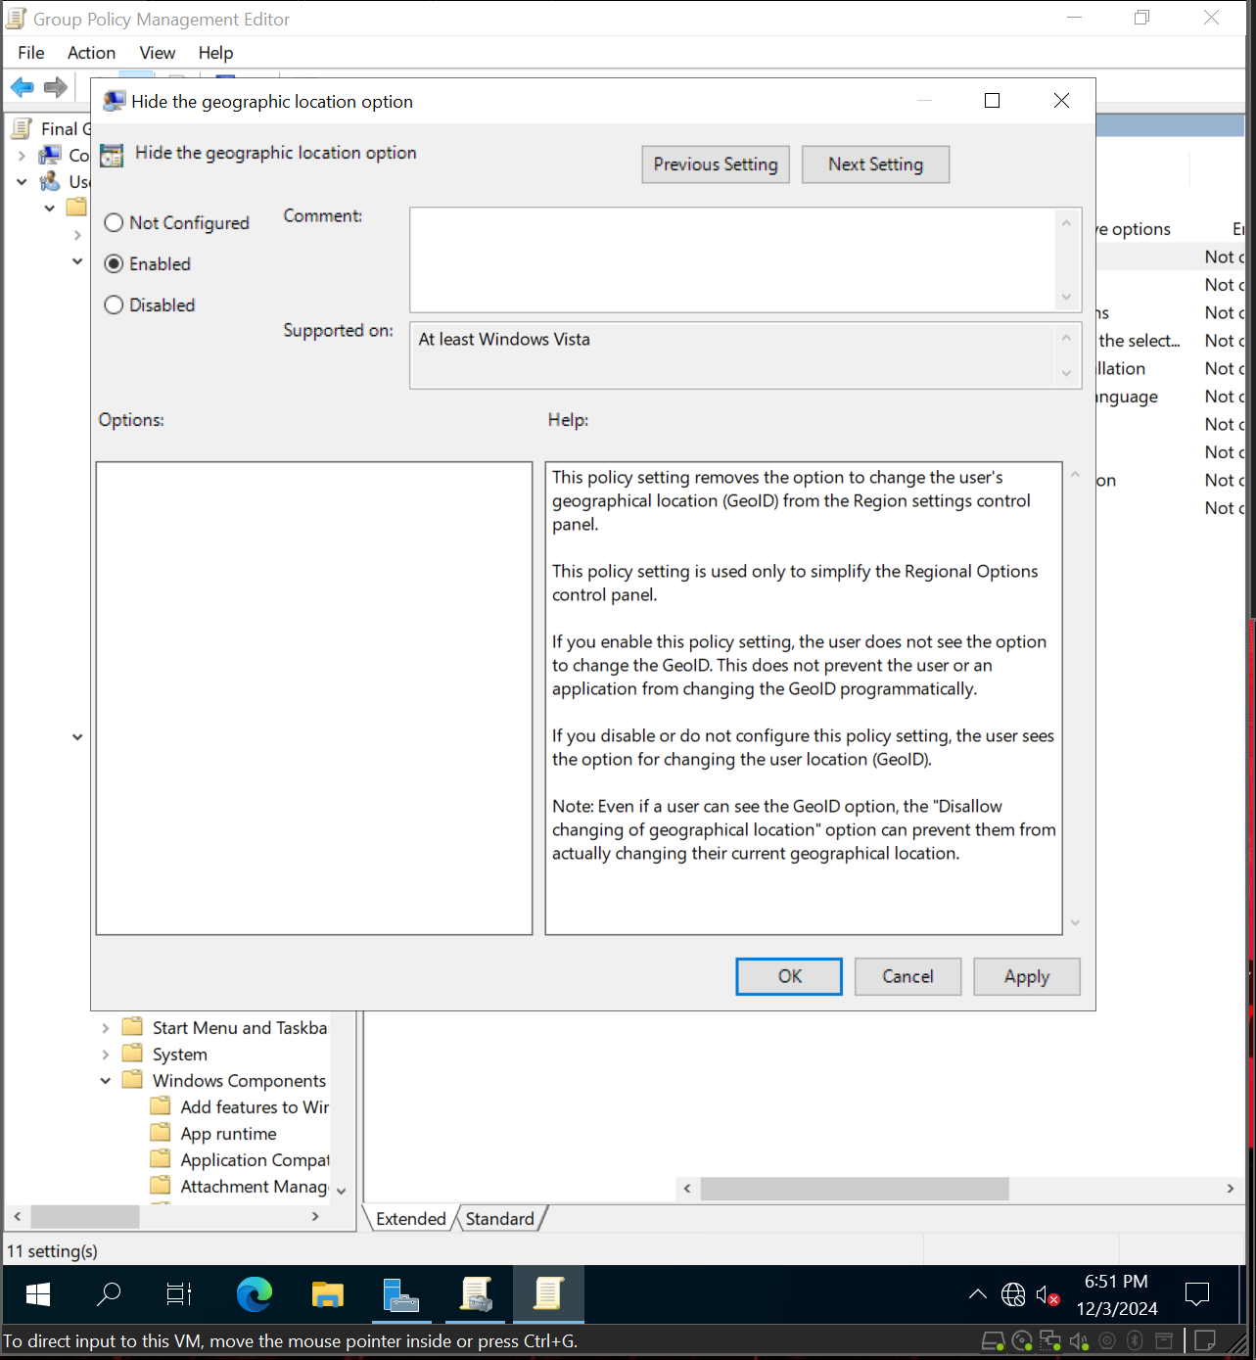  
Prevent users from changing their geographic location*